The Geology of the Marcellus Shale – Summer 2012
(Penn State University Geosc 297M, 3 credits)

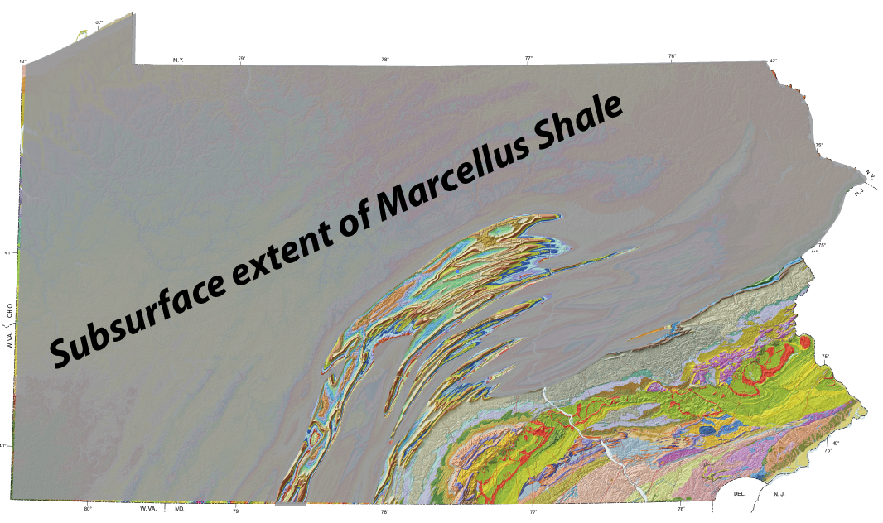

About this class
This class is a field-based introduction to the geological processes that result in the formation of oil and gas accumulations with an emphasis on the Marcellus Shale; it is also about the set of geological and geophysical tools and concepts that are used in exploring for and developing hydrocarbons. The class is aimed at beginning geoscience students who are interested in learning about the application of the geosciences to the discovery and extraction of hydrocarbons, particularly in the Appalachian Basin.
Prerequisites: no specific course requirements, but an interest in pursuing a major in science or engineering is desirable.
Dates: July 21 – August 10, based out of PSU’s University Park campus in State College
Cost: Tuition, room, and board is estimated at $2760 based on 3 credits at PSU; scholarships for under-represented students are available
How to Apply: complete and return the application form, available online at: www3.geosc.psu.edu/~dmb53/Geosc297M.
Application Deadline: April 1, 2012
Geology of Marcellus Shale Application

July 21–August 10, 2012
The application deadline is April 1, 2012, although we will begin reviewing and accepting applicants immediately. Final decisions about enrollment will be made by the instructors. Grades and career goals will be considered. A short interview (in person or by phone) may be requested. References may also be checked. Registration is not limited to Penn State students; interested students from other institutions are encouraged to apply.
1 Name: ______________________________________________________________________________
2 Penn State ID or SSN:* ________________________________________________________________
3 Name of university or college: ____________________________________________________________
4 Semester standing:_____________ 5 Grade-point average: ______ 6 [_] Graduate [_] Undergraduate 7 [_] In-state [_] Out-of-state 8 Are you a Penn State faculty/staff dependent? [_] Yes [_] No
9 Major (declared or intended)r: ____________________ 10 Minor, if any: ______________________
11 School address: ______________________________________________________________________
_______________________________________________________________________________________
_______________________________________________________________________________________
12 Local phone number: ___________________________________________________________________
13 Same address next semester? [_] Yes [_] No (If not, please give your address for next semester, if known.)
________________________________________________________________________________________
________________________________________________________________________________________
14 Home address: __________________________________________________________________________________________________________________________________________________________________________________
_________________________________________________________________________________________
*The Social Security number (SSN) you provide for enrollment purposes, or when requesting specific services, will be used by the University to verify your identity for official record keeping and reporting. If you choose not to supply your SSN, certain services—such as transcripts, enrollment verification, tax reporting, and financial aid — may not be available to you, and Penn State cannot guarantee a complete academic record for you. Your SSN will be stored in a central system and used only as a primary source to identify you within the Penn State system; the Penn State ID will be used as the primary identifier.
15 Home phone number: ______________________ 16 Email address: _________________________
17 What science/math courses have you taken?
_________________________________________________________________________________________
_________________________________________________________________________________________
18 In what ways might this experience be useful in your career development?
_________________________________________________________________________________________
_________________________________________________________________________________________
19 Describe any physical condition(s) you have that may be aggravated by hot weather or by working outdoors: _________________________________________________________________________________________
20 Name of your health insurance provider (You will be asked to submit proof of health insurance.): _________________________________________________________________________________________
21 Please provide two references, preferably one academic and one work-related:
_________________________________________________________________________________________
Name
Phone number and/or e-mail address
_________________________________________________________________________________________
Name
Phone number and/or e-mail address
Return the application form, via email to Professor David Bice (dmb53@psu.edu) no later than April 1, 2012

You will be notified by Dr. Bice regarding acceptance by April 15, 2012. Only those students who are accepted may enroll in the field school.

