Geoscience 001 Fall 2005 Exam #2 Version A

Be sure to enter the version of your exam on the test answer form!!
Be sure to darken the circles beneath your PSU ID
Some of the questions are worth more points than the others — these are indicated with their point values; the other questions are all worth one point.

1. 2 pts For potassium-argon radiometric dating, what is the minimum information do you need to calculate the age of a mineral (and therefore the rock that the mineral comes from)?
- Parent/daughter ratio
- half-life
- total amount of parent isotope at start
- a, b and c
- a and b

2. 2 pts For 14C radiometric dating, what is the minimum information do you need to calculate the age of a piece of organic material?
- 14C/14N ratio of sample and 14C half life
- 14C/12C ratio of sample and 14Chalf-life
- 14C/12C ratio of sample, presumed starting ratio of 14C/12C, and 14C half-life
- 14C/14N ratio of sample, 14C half life, and 14N half-life

3. Why is the sea level surface in gyre centers higher than in surrounding areas?
- low atmospheric pressure
- it is a buoyancy affect due to the lower density of the water
- ekman transport creates convergence of flow in the gyre center
- it is a buoyancy affect due to the higher density of water

4. Gyres in the southern hemisphere circulate:
- clockwise
- counter-clockwise
- from east to west
- from north to south
- c and d

5. What is the significance of finding shocked quartz at the K/T boundary?
- it demonstrates that there was a large impact at the time of the mass extinction
- it demonstrates that there was a huge, cataclysmic eruption at that time
- it tells us that there was a major drop in sea level at that time
- it tells us that the dinosaurs were doing shock-wave experiments before they became extinct
6. 2 pts Immediately following the K/T boundary, the shells of surface-dwelling organisms record carbon isotope values that are the same as those of bottom-dwellers. What does this tell us about the post-impact oceans?
- biological productivity in the oceans was effectively non-existent
- productivity among surface dwellers was unusually high
- productivity among bottom dwellers was unusually high
- productivity of the whole ocean was higher than normal

7. The Banded Iron Formations formed at a time that was:
- just after the rise of oxygen in the atmosphere
- just before the rise of oxygen in the atmosphere
- just after the invention of photosynthesis
- just before the invention of photosynthesis
- b and c

8. The iridium concentration in the K/T boundary clay tells us that:
- The extinctions must have taken place over a period of at least 5 million years
- There was a sudden addition of extraterrestrial material to the Earth at that time
- The sea floor was inhabited by toxic microbes that concentrated iridium from sea water
- The dinosaurs were experimenting with iridium fission technology that got out of hand.

9. 2 pts Why do deep ocean currents form in the North Atlantic, but not the North Pacific?
- The North Atlantic is colder and therefore denser
- The North Atlantic is saltier and therefore has the potential to become very dense
- The North Pacific is colder because of its lower salinity
- The North Pacific Ocean is too shallow to enable deep currents to form

10. 2 pts Why does an El Nino event harm the fishing industry off of South America?
- the increased precipitation reduces surface water salinity to the point of driving the fish away
- the increased thickness of the thermocline prevents the upwelling of cold, nutrient-rich waters
- the decreased winds weaken the ekman divergence that drives the upwelling of cold, nutrient-rich waters
- a and b
- b and c

North Atlantic Deep Water has a flow of 1x10⁷ m³/s and it involves a temperature change of 25°C. Given that water has a density of 1 x 10³ kg/m³ and a heat capacity of about 4000 Joules per kg per °C, answer the following:

11. What is the total mass of water involved in this flow each second?
- 1 x 10¹⁰ kg
- 2 x 10¹⁰ kg
- 1 x 10¹⁸ kg
- all of the above

12. What is the energy change (each second), per kg of water, involved in this process?
- 1 x 10⁵ Joules given off by the water
- 100,000 Joules taken in by the water
- 10,000 Joules given off by the water
- 1000 Joules taken in by the water

13. What is the thermal energy change each second during the formation of this deep ocean current?
- 1 x 10¹⁵ Joules given off
- 1 x 10¹⁵ Joules taken in
- 2 x 10¹⁵ Joules given off
- 1 x 10⁴⁵ Joules given off

14. 2 pts How does urbanization affect flood peak times and magnitudes?
- flood peaks are sooner, magnitudes are larger
- flood peaks are later, magnitudes are greater
- flood peaks are sooner, magnitudes are unchanged
- flood peaks are later, magnitudes are smaller

15. Building a dam obviously alters the gradient along a stream. How would this affect the stream above the reservoir?
- erosion of sediment
- deposition of sediment
- velocity reduction
- a and c
- b and c

16. How would this affect the stream below the reservoir?
- increased erosion
- deposition of sediment
- velocity increase
- a nd b
- b and c

17. Which of the following rock types is likely to be the best aquifer?
- limestone
- sandstone
- shale
- vesicular basalt
- granite

18. Why does the cone of depression that forms around a pumping well enable an aquifer to provide high rates of flow to the pump?
- it increase the permeability of the aquifer
- it increases the porosity of the aquifer
- it increase the local gradient of the water table
- a and b
- a, b, and c

19. 3 pts In the late 1700’s and early 1800’s, much of Pennsylvania’s forests were cleared for fuel at the same time that hundreds (perhaps even thousands) of small dams were built to power mills. The forest clearing facilitated erosion of the hillslopes, lowering the land surface by an average of 30cm (i.e., a lot of sediment was added to the system). Which of the following curves represents the most likely scenario for the output of the sediment at the downstream end of the system — the Chesapeake Bay?

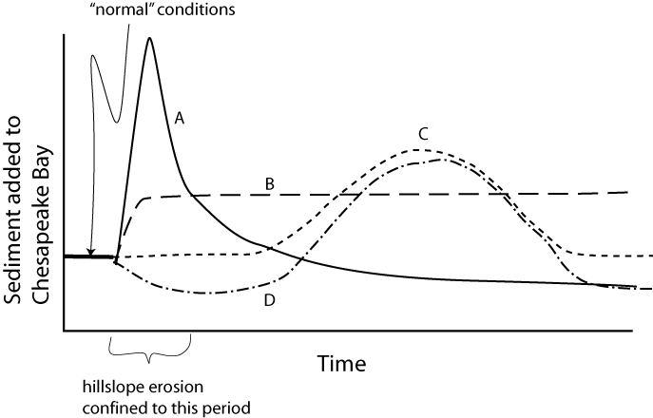
- A
- B
- C
- D

20. 2 pts Which statement best describes the relationship between chemical weathering of silicate rocks and the global temperature?
- weathering consumes atmospheric CO₂ and thus cools the planet, triggering an ice age
- weathering consumes atmospheric CO₂ and thus cools the planet, which slows weathering reactions, making for a global thermostat
- weathering consumes atmospheric O₂ and thus depleting the ozone layer
- the products of weathering lead to limestone formation, which adds to atmospheric CO₂ and thus warms the planet, leading to further weathering and further warming

21. Why is acid mine drainage such a problem in Pennsylvania’s surface waters?
- it is due to acid rain, falling on the surface and leaching toxic metals from mines
- it is because coal contains pyrite, which when exposed to the surface and the microbes living there, undergoes oxidation and generates acid
- it is because the coal is naturally acidic and any contact with water turns the water acidic

22. 2 pts Landslides tend to occur after heavy rainfalls because:
- the water simply lowers the friction in the soil and rocks near the surface, making slip possible with previously safe levels of shear stress acting on the slope
- the water increase the normal force, promoting slip
- the pore fluid pressure reduces the effective normal force or stress, lessening the shear stress needed to overcome friction
- stream erosion associated with floods undercuts slopes and makes them unstable

23. 2 pts Dating the water in an aquifer shows that its average age is 10,000 years and the volume is 1 x 10⁸ m³. Assuming that the inflow (or recharge) and outflow (discharge) are normally in balance, what is the value of the recharge?
- 1 x 10² m³/year
- 1 x 10¹² m³/year
- 1 x 10⁴ m³/year
- 1 x 10⁵ m³/year

24. Regions with shale bedrock at the surface are more susceptible to landslides because:
- the coefficient of friction in shale is lower than in most other rocks
- the shale makes an impermeable cap that prevents water from infiltrating downward
- the shale weathers more easily, forming thick clay-rich soils
- all of the above

25. 2 pts Why does urbanization lead to changes in the flooding behavior of streams?
- straightened channels are more prone to flooding
- excessive use of groundwater adds to the water that streams must carry away from a region
- decreased infiltration increases the amount of rainfall that runs off over the surface and enters streams in a heavy rain storm

26. 2 pts What is the El Nino phenomenon?
- it is the divergence-related upwelling of cold, nutrient-rich waters along the equatorial Pacific
- it is the formation of huge volumes of salty, cold water each Christmas that accounts for the North Atlantic Deep Water current
- it is the eastward movement of warm water along the equatorial Pacific, one part of a semi-periodic oscillation due to the interactions of wind and water masses
- it is the cooling effect of the southern polar regions caused by the circum-Antarctic current

27. 2 pts From the standpoint of chemical weathering of silicate rocks, which of the following scenarios is likely to lead to a cooler planet?
- continents massed near the two poles
- continents massed near the equator
- continents massed near the equator with active mountain uplift
- continents massed near the poles with active mountain uplift
- continents uniformly distributed across the globe

28. How are clay minerals formed?
- volcanic eruptions
- planktonic organisms living in the tropical oceans
- chemical weathering of feldpsar
- chemical weathering of quartz

