Geoscience 001 Fall 2005 Exam #1 Version B
answers at end of exam
Be sure to enter the version of your exam on the test answer form!!

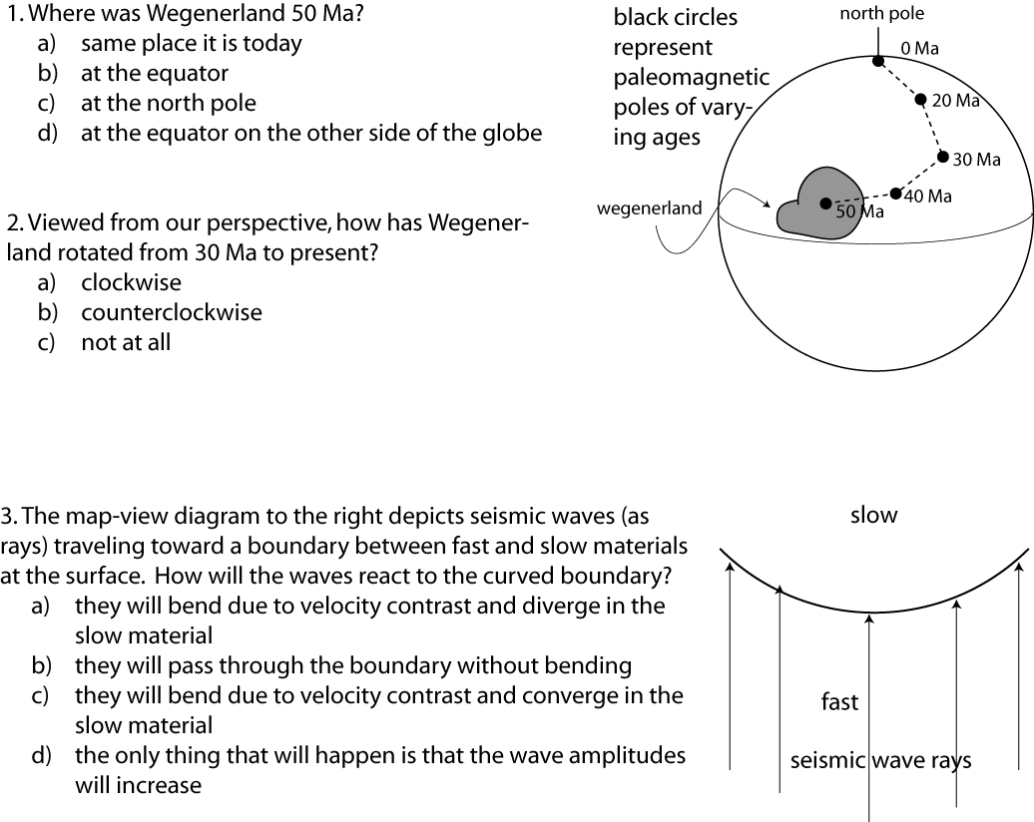

4. Does magma formed at mid-ocean ridges have the same composition as the mantle?
- yes — both are composed of basalt or gabbro
- yes — both are composed of peridotite
- no — the ocean crust is basaltic and the mantle is peridotite
- no — the ocean crust is peridotite and the mantle is basalt

5. What is the composition of most of the magma formed at a subduction zone?
- basaltic
- andesitic
- granitic and basaltic
- basaltic and andesitic

6. How is magma made at a subduction zone?
- frictional heating as one plate slides by another
- increased pressure inevitably leads to melting of the subducting plate
- water released from the subducting plate lowers the melting point of the overlying mantle
- increased temperature leads to melting of the subducting plate

7. How does magma form at a mid-ocean spreading ridge?
- water circulates down into the mantle and triggers melting by lowering the melting point of the mantle
- the underlying mantle is molten everywhere and simply rises to the surface where it gets a chance; the diverging plates provide that chance
- mantle rising to fill the void created by diverging plates undergoes a pressure decrease that triggers partial melting of the mantle

8. How do we know that the outer core of the earth is liquid?
- P-waves slow down as they pass through this region
- S-waves do not pass through this region
- Neither P-waves nor S-waves pass through this region

9. What is the origin of the magnetic anomaly stripes on the ocean floors?
- Reversals of the magnetic field recorded by crust formed at a spreading ridge
- Faulting of the ocean crust that raise and lower the magnetized rocks of the ocean crust
- They reflect times when chemical alteration along a mid-ocean ridge was strong (negative magnetic anomaly) or weak (positive magnetic anomaly)

10. A 90 Ma old basalt (formed at a time when the magnetic field had a normal polarity) has a magnetic declination of 45° and an inclination of -45°. Recall that tan(inclination) = 2tan(latitude). What latitude did the rock form at?
- 26° South
- 45° North
- 26°North
- 45° South

11. Antarctica is surrounded on all sides by divergent plate boundaries, and yet the center of the plate is not experiencing compression. What does this mean?
- “Ridge push”, as a driving force is not that strong
- The Earth is expanding
- The mid-ocean ridges surrounding Antarctica must be moving away from the center of the plate
- both a and c
- a, b, and c

12. If a volcanic arc is located about 100 km from the trench, what can be said about the dip of the subducting plate?
- it dips at a 60° angle with respect to horizontal
- it dips at a 30° angle with respect to horizontal
- it dips at a 45° angle with respect to horizontal

14. What happens to seismic waves when they pass from a fast material to a slow material?
- they speed up and the amplitude decreases
- they slow down and the amplitude decreases
- they speed up and the amplitude increases
- they slow down and the amplitude increases

15. How do we know the size (depth below the surface) of the outer core?
- from studies of the moment of inertia
- from the size of the S-wave shadow zone
- from the size of the surface wave shadow zone
- from theoretical calculations assuming that the whole Earth has the same composition as meteorites

17. How did the Moon form, according the currently favored theory?
- gravitational capture of the Moon by the earth
- fission from the earth during a period of rapid spin
- an unusual consequence of normal accretion
- remnants of a gigantic impact

18. Crystal size in igneous rocks is a function of:
- rate of cooling; faster cooling = larger crystals
- rate of cooling; faster cooling = smaller crystals
- composition: basaltic magma = smaller crystals
- tectonic setting; igneous rocks from subduction zones always have larger crystals

19. The most explosive volcanic eruptions come from:
- Hawaii, the largest volcanic structure on Earth
- Andesitic volcanoes, which are the tallest of all volcanoes
- Rhyolitic volcanoes, which tend to occur as big holes in the ground
- Oceanic hotspot volcanoes

20. If you live near one of the Cascades volcanoes, what kind of eruptive product poses the biggest threat to the most people?
- lahars (volcanic mudflows) because they travel the farthest, reaching population centers
- pyroclastic flows because they are the fastest and involve toxic gases
- lava flows because they are unstoppable
- volcanic ash because it gets everywhere

21. Much of New Orleans is 3 meters below sea level. A simple solution to their problems might include adding 3 meters of sediment to the whole area, bringing it right up to sea level. What does the principle of isostasy tell us about what will happen following this addition of weight?
- the ground surface will quickly return to the 3 m below sea level position, which is the equilibrium elevation given the crustal thickness in this area
- the ground surface will remain at sea level, which is the true equilibrium position
- the ground surface will slowly subside to something closer to 1 m below sea level

22. Carbonate sediments principally form in what kind of environment?
- lakes
- rivers
- deserts
- oceans
- swamps

23. Particle size in carbonates is a function of:
- geologic age; older carbonates have smaller particle sizes
- combination of geologic age and latitude
- combination of wave energy and kinds of organisms present in the environment
- purely a function of transport time between the source and the site of deposition

24. Based on the cross-beds shown in the diagram below, what was the direction of current flow?
- left to right
- right to left
- top to bottom

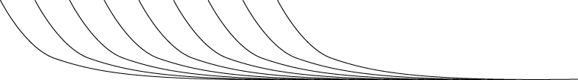

25. What can you infer from stromatolites?
- the depositional environment was calm, with cool, fresh water
- the depositional environment was shallow, with cool, salty water
- the depositional environment was a swamp
- the depositional environment was shallow, tropical, marine

26. In the diagram below, where is the mid-ocean ridge located?

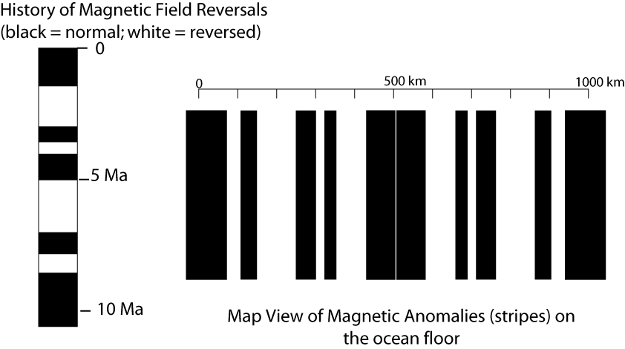
- near the 0 km mark on the map
- near the 300 km mark on the map
- near the 1000 km mark on the map
- near the 500 km mark on the map

27. What is the full spreading rate represented by this map and associated history of magnetic field reversals?
- 50 km/Ma
- 100 km/Ma
- 25 km/Ma
- 500 km/Ma

Answers to Practice Exam

1 c
2 a
3 c
4 c
5 d (partial credit for b)
6 c
7 c
8 b
9 a
10 a
11 d
12 c
14 d
15 b
17 d
18 b
19 c
20 a
21 c
22 d
23 c
24 a
25 d
26 d
27 b

