Name:
Lab Section:
work in groups, but each person turns in his/her own

Geoscience 001 Lab Understanding Geologic Maps

Geologic maps are colorful and even beautiful, but they also contain an amazing amount of information. They show the topography of the surface, the types of rocks found over the entire surface, the ages of the rocks, the orientation of the rocks, the locations of faults and folds, and the relationships of the rocks to each other and the land surface. In essence, the whole geologic history of a region is contained in the information provided by a geologic map. As much work goes into making a geologic map as goes into the writing of a typical book — some intrepid geologist has usually explored every square foot of a region in order to fully understand the geology. We’re talking blisters, sunburn, sweat, cold, rain, and challenging problems, but also great scenery, fresh air, and fun too.

In this lab, we will study and analyze geologic maps from a few regions, including the Grand Canyon, western Wyoming, and coastal California.

Background to Study Before Lab

First, we need to review a few basic concepts.

Strike and dip of bedding planes or other planar features such as faults.
Study the diagram on page 335 of your text.

Intersections of tilted planes (layers or faults) and topography
Study the movie called tilted bed to observe the relationship between planar features (could be a sedimentary bed or a fault plane) and topography, then come to lab prepared to answer questions about the relationship between geologic layers and topography. The following maps depict a layer (stippled) with topographic contour lines. Study these and see if you can figure out the tilt (dip) amount and dip direction in each case. (answers on following page).

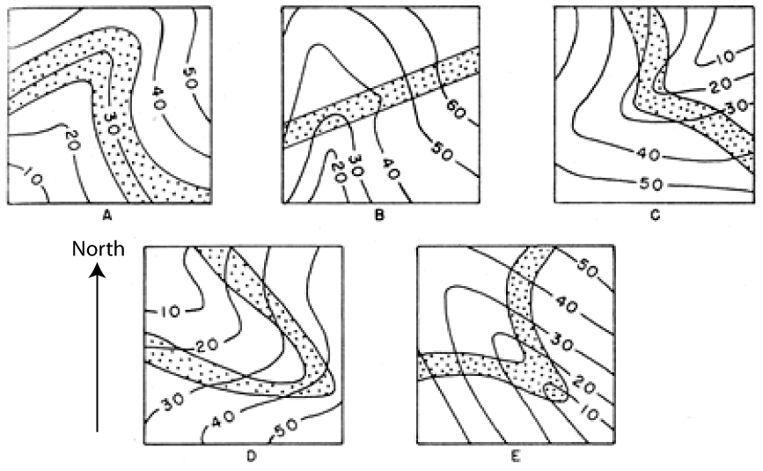
A — horizontal layer (dip=0). B — vertical layer (dip=90). C — dipping steeply to the SW. D — dipping gently to the NW. E — dipping moderately to the SE.

If the layers are horizontal, their contacts will be parallel to the topographic contours. If they are tilted, you can find the strike by making a line that connects 2 points of equal elevation on a contact — find where a contact crosses the same topo contour twice and connect the points. Then look perpendicular to the strike line and find direction in which the beds goes to lower elevations — that is the dip direction

Cross-Cutting Relationships
Study pages 380-382 of your text.

Construction of cross-sections — predictions of the subsurface geology.
Starting with a topographic profile and information on the locations and dips of formation boundaries (contacts, as they are called), your aim is to extend the contacts, faults and other features below the surface — this amounts to a prediction of where different rock units are found below the surface, On occasion, you have information from wells in the vicinity that provide useful constraints on the sub-surface geology.

Study the cross sections that accompany the other maps and see how sedimentary formations are usually portrayed. In most cases, they are shown with a uniform thickness (thickness of each layer is constant, but different layers have different thicknesses) and they undergo smooth folds or are truncated abruptly and offset by faults.

The Grand Canyon

1. Based on map evidence and the ages of various formations and deposits, when did the erosion of the Grand Canyon begin? Describe the reasoning behind your answer.

2. Study the relationship between the topographic contours and the contacts of the Coconino Sandstone all around the East Kaibab Monocline, located in the NE part of the map.
a) a) What is the approximate strike, dip, and dip direction of the Coconino just to the west of the word Wildcat, which is west of the letter E in EAST KAIBAB? (Strike ± 30°, Dip ± 10°)
Strike
Dip
Dip Direction

b) What is the approximate strike, dip, and dip direction of the Coconino just to the east of the letter K in EAST KAIBAB? (Strike ± 30°, Dip ± 10°)
Strike
Dip
Dip Direction

3. How thick (± 80’) is the Hermit Shale in the following areas:
The SW corner of the map, just above the scale for the map, near the second N in COCONINO.

4. How much topographic relief was there at the beginning of the Cambrian? Go to the top center of the map and find the structure called the Crazy Jug Monocline (running roughly North-South) taking off from the E in EASTERN of the map title — follow this down to the south, about half-way, and find the area called Monadnock Amphitheater (just west of the word JUG). In this area, there are two exposures of the unit labeled PCs with smaller bits of unit PCh (colored brown) adjacent to them. Study the geology in this area, extending to the SW towards the river, and determine the maximum elevation difference between the Cambrian sediments and the Precambrian rocks — this is a measure of the topographic relief in one small area.
Maximum relief =

5. What is the displacement history — timing of movement and amount of movement — along the East Kaibab Fault, as depicted in the geologic cross-section D-D’ shown at the bottom of the map?

Jackson Hole, Wyoming

This map, the Camp Davis Quadrangle, shows the geology at the southern end of Jackson Hole, a beautiful valley along the eastern edge of the Grand Teton Mountains.
6. The goal here is to complete a geologic cross-section along the line A-A’, which crosses the Hoback Fault in order to figure out how much offset (displacement) there has been on the fault. Use the topographic profile provided, along with some information from the wells, and information from the map to complete the cross-section to a depth great enough to show where the Chugwater Formation intersects the fault on either side. Use the offset of either the top or bottom contact of the Chugwater to determine the fault displacement. The thicknesses of many formations can be obtained from the map legend. Pay attention to the mapped locations of the Willow Creek Anticline and the Willow Creek Syncline, which intersect the line of your cross-section (and therefore must be depicted in your cross-section). Also pay attention to the dips of different units near your cross-section — these tell you the angle to portray in your cross-section in the area where the measurements are shown. Just to the west of the Hoback Fault, there are several huge landslide blocks that occur on top of and within the Camp Davis Formation — these are big enough and intact enough that they are mapped with contacts, but we will ignore these in drawing the cross-section.

The cross-section template also shows the approximate extent of the Quaternary deposits (younger than 2 Ma) that make a thin veneer covering the older sedimentary formations that will make up the vast majority of the space in your cross-section. These Quaternary deposits cover the older formations, so you may have to look to either side of the cross-section line to find information ont eh strike and dip of beds. In general, if the strike of a bed is perpendicular to your cross-section line, you can use the dip measurement to draw the beds in cross-section; but if the strike is oblique to the section line, the dip shown in your cross-section will be a bit less than the true dip shown on the map.

The template also shows locations of faults at the surface, with their approximate dips; contacts not covered by Quaternary deposits are also shown.

a) complete the cross-section

b) Displacement (measured in feet along the fault) =

c) What kind of a fault is this? What kinds of forces, applied in what direction are implied by this fault?

Coastal California

This map is from the so-called Transverse Ranges, north of Los Angeles, fairly close to the San Andreas Fault, in an area where the Fault makes a significant bend. The bend means that the two plates (remember that the San Andreas is a plate boundary) do not slide by each other very easily here, leading to complex faulting and folding — a very interesting area.

8. With this map, we’re going to focus on the Big Pine Fault, which is the big fault striking roughly E-W in the northern half of the map. How much offset has there been along the Big Pine Fault? Study the map carefully on either side of the fault and locate geologic markers (features like fold axes, formation contacts, older faults, etc.) that can be used to estimate the amount of displacement. In many cases, this amounts to some experimentation, reversing the motion along the fault and then seeing what matches up across the fault.

a) List these in the form of a table (in the space below) that describes the marker, the slip implied by each of the markers, and the age of the marker, and then finally, the average rate of displacement.

b) Which of these markers gives the most reliable, recent rate of displacement? Explain your reasoning.

