Names:
Lab Section:
each group of 2 turns in one lab

Geoscience 001 Oceanography Lab

This is a computer-based lab exercise in which we will use an incredible computer resource to visually explore a huge quantity of oceanographic data in order to learn some fundamental things about the oceans.

Background to Cover Before Lab

The IRI Data Viewer is maintained by Columbia University’s Lamont Doherty Earth Observatory, which is one of the world’s largest research centers. They have collected and organized a vast range of data, including data on the world’s oceans. In this lab, we will be using a data set that shows the following parameters for the whole world ocean, in 3-D:
Salinity, density (and potential density), temperature (and potential temperature), phosphate, phosphate*, nitrate, silicate, dissolved oxygen, chlorophyll, and a few others.

The data are presented as annual averages, as monthly averages, and as seasonal averages, so you can see how these parameters vary over time too. There are numerous other data sets at this site; the whole range of them can be found at this page: http://iridl.ldeo.columbia.edu/docfind/databrief/cat-ocean.html

First, get to know the Data Viewer program and how to manipulate it, by going to the site and working through the tutorial before coming to lab. The full tutorial is a lengthy affair, but if you work through the Visualizing Data section (http://iridl.ldeo.columbia.edu/dochelp/Tutorial/MVD/Visualization/ ), you should be in good shape — ignore the parts that deal with the expert mode. Click on examples 1 and 5 to learn how to map a map and a vertical slice.

If you try to do the lab problems without going through the tutorial, you’ll be frustrated, sad, and you will run out of time.

At a minimum, you need to be able to view the data at different scales, zoom in and out; change the depth; change the values plotted on the horizontal and vertical axes to either see a map view, or a cross-sectional view of the ocean; and change the values of the ends of the color bar to highlight the variability in some areas of the oceans. Note that when you make a cross-sectional view, where depth is along the vertical axis, the program default puts the surface at the bottom of the page and the bottom of the ocean (where the depth is greatest) at the top; you ought to reverse the values on this axis so that up is up (0 in the top box, 5500 in the bottom to see the whole ocean).

It is also helpful to know how to make an animation, which can save you some time in making repeated views of the data — this is all explained in the tutorial. Just as an example, though, if you go to this data set: http://iridl.ldeo.columbia.edu/SOURCES/.LEVITUS94/.ANNUAL/.temp/ and click on the map view up near the top center of the screen. Then go to the uppermost box in the center where you can set the depth, type 0 to 5750 and then hit redraw; you’ll see an animated map of the temperature going from the surface down to the bottom — pretty cool (at least at the bottom).

Deep Water Formation

At present, the world’s oceans are thoroughly mixed on a timescale of just a few thousand years. The surface circulates and mixes due to the effects of wind-generated currents, while the deep waters are mixed more sluggishly by a system of deep currents that form near the two poles. The deep currents effectively ventilate the world’s oceans, bringing oxygen (and CO₂) into the deep parts of the oceans. This is part of the reason that the oceans have the capacity to hold a huge quantity of CO₂. But how does this system work? What drives it? What determines where and when and how much deep water is formed? These are some the questions we’ll try to answer in this lab.

Deep water formation is all about density, and density is a function of temperature and salinity, as shown in the diagram below. The curved lines represent lines of equal density and you can use this diagram to figure out the density of water knowing the temperature and salinity. You can also use this to predict how much the density will change if you change the salinity or temperature from some starting condition.
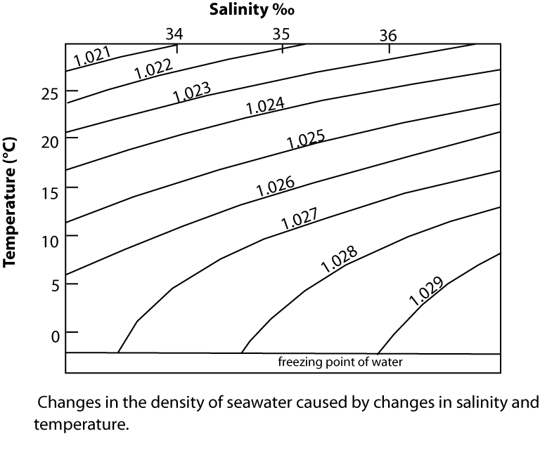
To get surface waters to sink, their density (ρ) must exceed the density of the underlying waters, and much of the deeper waters of the oceans are around 1.028 g/cm³. This is not an easy thing to do, so there are very few places around the earth where deep water can form.

A. Where does the deep water filling the world’s oceans form?

We’ll look for some answers by using chemical tracers. There are many ways of doing this, but one of the best is to use a parameter called ‘phosphate-star’, which combines phosphate and oxygen concentrations in the following way:

PO₄*= PO₄ + O₂/175 − 1.95 μmol/kg

The thinking behind this is that the value of phosphate star is effectively established at the surface or the ocean and it should remain nearly constant if the water sinks and heads into the deep ocean. Phosphate is a nutrient for primary producers in the oceans and if they consume phosphate, they release at lot of oxygen, which is added to the water. When organisms die, their remains are consumed by microbes in a process that consumes oxygen and releases phosphate back into the water. So, either way, the phosphate star value stays the same, making it a ‘conservative tracer’ that can be used to track different water masses moving around in the oceans.

For this question, you will go to the LEVITUS94 data set, starting with the annual average data: http://iridl.ldeo.columbia.edu/SOURCES/.LEVITUS94/.ANNUAL/ .

NOTE: for the following questions, your answers have to refer to actual data — you need to support your answers with facts, and those facts can take the form of a graphic, an image from the program, or a kind of numerical summary of what you see in the images generated by the program. So, for this first question, simply saying Antarctica or North Atlantic is not sufficient — you need to say, with some precision, what the basis is for choosing one or the other as the main source of the deep water.

1. Where does most of the deep water come from — Antarctica or the North Atlantic? (along the way here, you need to answer the following: what is the PO₄* value around Antarctica? What is the PO₄* value around the North Atlantic, just north of Iceland? What are the deep ocean PO₄* values as seen in cross-sections from north to south through the Pacific and Atlantic?) Be sure to read the above paragraph before answering this question — this same message applies to the rest of the questions in this lab too.

From the cross section below, you can see that the North Atlantic and about half of the southern Atlantic are filled with water that appears to come from the area up by Iceland (PO4* values of around 0.5), whereas most of the Pacific (and thus, most of the water in the oceans) ranges in values from 1.3 to 1.5, meaning that it comes from Antarctica. This assumes that the PO4* values do not really change much.

2. Which water mass (North Atlantic or Antarctic) is denser? You can tell this by how they interact in places where they meet — the denser one will obviously flow underneath the lighter one. (Note that the answer might be a bit more complex than just this one is denser than the other one.) This is best seen in a cross-section through the Atlantic.

3. Is the NADW confined to the Atlantic? Or does it spill into the other oceans?

The next questions will lead to an understanding of why there is no deep water formation in the North Pacific.

4. a) Which is saltier at the surface — the North Pacific or the North Atlantic? Consider 30°N and 60°N in each ocean and tabulate the salinities.

b) Based on salinity, which region is most likely to produce deep water? Here, it will help to refer to the T-S-ρ diagram above showing density at different temperatures and salinities.

5. In order for deep water to form, the surface layer needs to become temporarily denser than the underlying water, but this is only a temporary condition even in places where deep water does form. For much of the year, and in fact, on average, the surface waters are always less dense than the deeper waters.

a) Study map views of the North Atlantic and North Pacific, plotting the potential density (which adjusts for the effects of pressure on deeper water and is thus the best way of directly comparing the surface and deep water densities). Where (give approximate latitudes and longitudes) are the densest waters found at the surface in these regions? You will have to alter the color bar end values to highlight the specific locations most clearly.

b) These would be the areas where you could most easily make the surface waters temporarily denser than the deep waters by making them colder (as long as the cold was not accompanied by increased rainfall, which would reduce the salinity). Look at depth profiles beneath these two regions to see how much denser the surface would need to get in order to sink to the bottom (or close to the bottom). Is the needed density increase possible?

B. Biological Productivity in the Oceans

The next major question we will consider has to do with whether or not the biological productivity of the surface oceans is maximized — whether or not the plankton are utilizing all of the available nutrients. The reason this matters is that these plankton represent a ‘biological pump’ on carbon dioxide, sending it directly down to the deeper parts of the oceans, where it can stay sequestered for a long time. Some people have pointed out that if it were possible to enhance this pump, we could draw down atmospheric CO₂ and counteract global warming.

First, let’s explore a few things related to nutrients in the oceans. Almost all nutrients ultimately come from weathering of the continents, via rivers. They are utilized by primary producers like phytoplankton (photosynthesizers), and then cycled through the food chain, but when organisms die or when they discharge fecal material, the nutrients descend into the deeper waters of the oceans.

1. Go to this data set: http://iridl.ldeo.columbia.edu/SOURCES/.NOAA/.NODC/.WOA01/.Grid-1x1/.Annual/.an/ where you can plot some important data related to nutrients and biological activity. Based on your analysis of N-S cross-sections through the Atlantic and the Pacific, are the nutrients (phosphate and nitrate) more abundant in the surface waters or the deep waters? Is one ocean more nutrient rich than the other? If so, why might this be?

2. What’s going on right below the equator in the Pacific? First, examine the surface concentration of phosphate, and compare it to what is observed just north and south of the equator. Then look at phosphate in a cross-sectional view across the equator. Finally, look at the temperature at the surface in this equatorial zone. In trying to explain these observations, it might help to realize that since there are places in the oceans where surface waters sink into the deep (downwellings), there must be places where deep water rises up to the surface (upwellings). These upwellings will tend to occur in places where the surface currents diverge, permitting deep water to rise.

Next, let’s look into the spatial distribution of phytoplankton, as indicated by chlorophyll content of the surface waters. Make a map of chlorophyll concentration in which you rescale the colorbar to go from 0 -1.5 in order to show the variability in the bulk of the oceans. Gray areas in this view are places where the chlorophyll values are > 1.5 (areas of high-productivity).

3. In general, which area has more phytoplankton productivity — the northern oceans, or the southern oceans ringing Antarctica?

The above differences between northern and southern oceans observed in the chlorophyll map could be due to nutrient limitations or some physical limitation like lack of sunlight or cold temperatures. Let’s explore the nutrient limitation hypothesis by comparing the phosphate concentrations of the two areas. Phosphate is one of the main nutrients for phytoplankton (along with carbon and nitrate, and a few others, including iron) and if the biological productivity is maximizing the nutrient supply, there will be little phosphate actually in the water (because it will be incorporated into the organisms). So, if you find low chlorophyll and high phosphate, that means the productivity is not living up to its potential.

4. Which of the two areas (northern oceans or southern oceans) is doing the best job of living up to its biological productivity potential, and which has substantial room for improvement?

