Name:
Lab Section:
each person turns in one lab

Geoscience 001 Lab: Streamflow and Flooding of Spring Creek

Materials: notebooks, calculators, meter sticks, tape measures, stopwatches, a couple of oranges, clothing appropriate for working in a stream on a cold day.

In this lab, we’re going to study the stream flow and the size of boulders in Spring Creek near Houserville, just a couple of miles NE of campus, with the goal of understanding some things about stream behavior and the history of flooding. We will divide ourselves into groups of 4; 2 people will measure the channel cross-section, the others will measure the velocity and measure the largest clast size in your section of the river.

For this lab, you need to come prepared to get a bit wet — there is no other way to study streams! We have some waders, but you should nevertheless bring old shoes or sandals that can get wet and wear some pants that can be rolled up so that you can wade out into the stream. Bring plenty of warm clothing for the parts of you that are not wet. Our time at the stream is short enough that no one needs to worry about hypothermia.

Measuring Discharge

Part of this lab will involve using data collected at a US Geological Survey stream monitoring gauge near Houserville; this gauge monitors the stream depth, which can be converted through the use of a rating curve, into the discharge of the stream — the volume of water moving through the channel over a given time period (usually expressed in cubic feet per second). We will use these data to calculate the 100 year flood, which is planners use to dictate where people should and should not build near a stream.

In order to gain a better understanding of what discharge means, we’re going to make some measurements of our own. This requires doing two things: measuring the cross-sectional profile of the stream, and then measuring the velocity at a few points along the cross-section. The details of this are shown in the figure below.
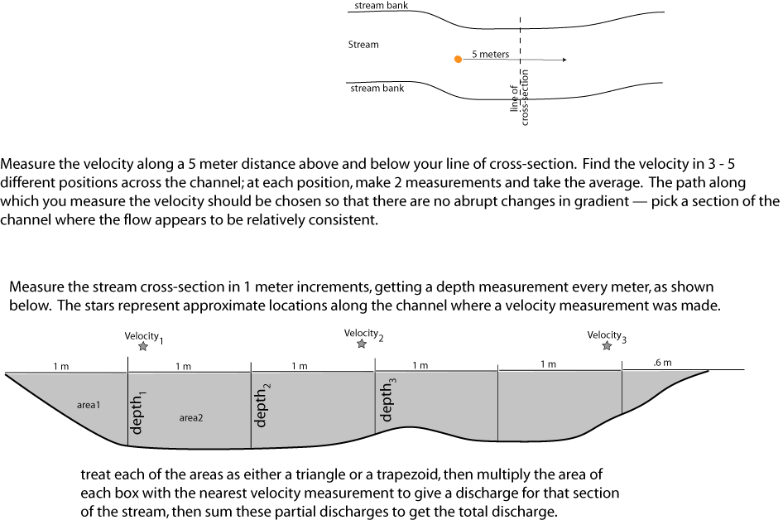

Plot your cross-section on the graph below, showing the velocity measurements as well.

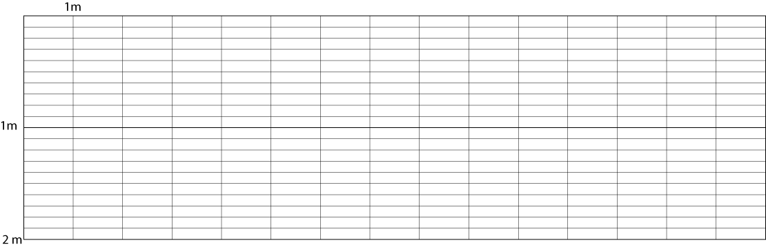

area

v * 0.7

Disch-arge
Note: you take 70% of the surface velocity in order to approximate the average velocity from the surface to the bed of the stream (where the velocity diminishes).

Sum the discharge boxes and write the total discharge here (don’t forget the units): .

Estimating Maximum Flood From Clast Sizes

The other task while in the field will be to measure the largest clast size in the portion of the stream where you measured your cross-section. You may have to look 5 meters upstream or downstream to get what appears to be the biggest clast. You need to be a bit careful here because large boulders have been brought to the channel to make small dams or to try to prevent bank erosion — you want to measure something that has definitely been transported by the river. Once you’ve located the biggest clast, measure the intermediate dimension, imagining that it is approximately some kind of rectangular cube that would have three mutually perpendicular dimensions.

Write your clast size here in mm:

Below are some data that show the relationship between shear stress and clast size for a range of values. Either graph these data and use a best-fitting line to project the shear stress inferred by your largest clast size, or use the data to make an equation for a line, then apply that equation to the clast size you measured.

Clast Name | Int. Diam (mm) | τ_{crit} (Pa)
Boulders | 256 | 248.976
Cobbles | 64 | 62.244
Very Coarse Gravel | 32 | 29.686
Coarse Gravel | 16 | 15.322
Medium Gravel | 8 | 7.661
Fine Gravel | 4 | 3.352
Very Fine Gravel | 2 | 1.412
Very Coarse Sand | 1 | 0.589
Coarse Sand | 0.5 | 0.259
Medium Sand | 0.25 | 0.174
Fine Sand | 0.125 | 0.147
Very Fine Sand | 0.0625 | 0.123

Write your shear stress(inferred by the largest clast) here:

Then, use the formula relating critical shear stress (the shear stress at the stream bed needed to initiate movement) to water depth to estimate the water depth implied by the clast.

τ=ρghsinα

where τ is shear stress (in units of Pascals, which are Newtons/m²), ρ is density (for water, 1000 kg/m³), g is the acceleration of gravity (9.8 m/sec²), h is the water depth (in meters) and α is the slope (in degrees) of the stream, which here has a drop of 20’ over a distance of 5100’.

Write your clast-inferred water depth here:

Is this a maximum or minimum water depth? (think about what would happen if you had a stream bed that simply had no large boulders and there was a huge flood that could easily have transported clasts larger than anything present in the stream bed).

Next, we move on to consider how this water depth compares with the 100-year flood. This is work to be done outside of the lab period.

Analysis of Historical Streamflow Data from Houserville

Estimate the 100-year flood discharge and gauge height for Spring Creek in Houserville using the data provided. First, calculate the Rank (1 being the flood with the greatest discharge) and Recurrence Time, using the formula RT=(n+1)/m (n is the number of yearly peak flood data — 20 in this case, and m is the rank of the peak discharge), filling in the results for the table below.

Year | Date | Gauge Height (ft) | Discharge (cfs) | Rank | Recurrence Time
1985 | Feb. 12, 1985 | 4.93 | 318
1986 | Mar. 15, 1986 | 6.79 | 687
1987 | Apr. 04, 1987 | 5.54 | 440
1988 | Aug. 29, 1988 | 4.98 | 351
1989 | Jun. 21, 1989 | 5.62 | 476
1990 | Jun. 09, 1990 | 5.05 | 364
1991 | Oct. 23, 1990 | 5.62 | 476
1992 | Dec. 03, 1991 | 4.55 | 269
1993 | Apr. 01, 1993 | 7.14 | 835
1994 | Mar. 25, 1994 | 7.02 | 800
1995 | Jan. 20, 1995 | 5.55 | 466
1996 | Jan. 19, 1996 | 10.05 | 2,370
1997 | Oct. 19, 1996 | 6.79 | 748
1998 | Apr. 09, 1998 | 6.14 | 599
1999 | Jan. 24, 1999 | 7.13 | 832
2000 | Jun. 15, 2000 | 5.09 | 363
2001 | Aug. 19, 2001 | 5.36 | 423
2002 | Jun. 06, 2002 | 6.98 | 795
2003 | Aug. 03, 2003 | 6.89 | 772
2004 | Sep. 18, 2004 | 9.76 | 2,110

Next, plot the data on the semi-log graph below, and extrapolate to the 100-year event by using a best-fit straight line. Note that this must be done with logarithmic scale for the x-axis.
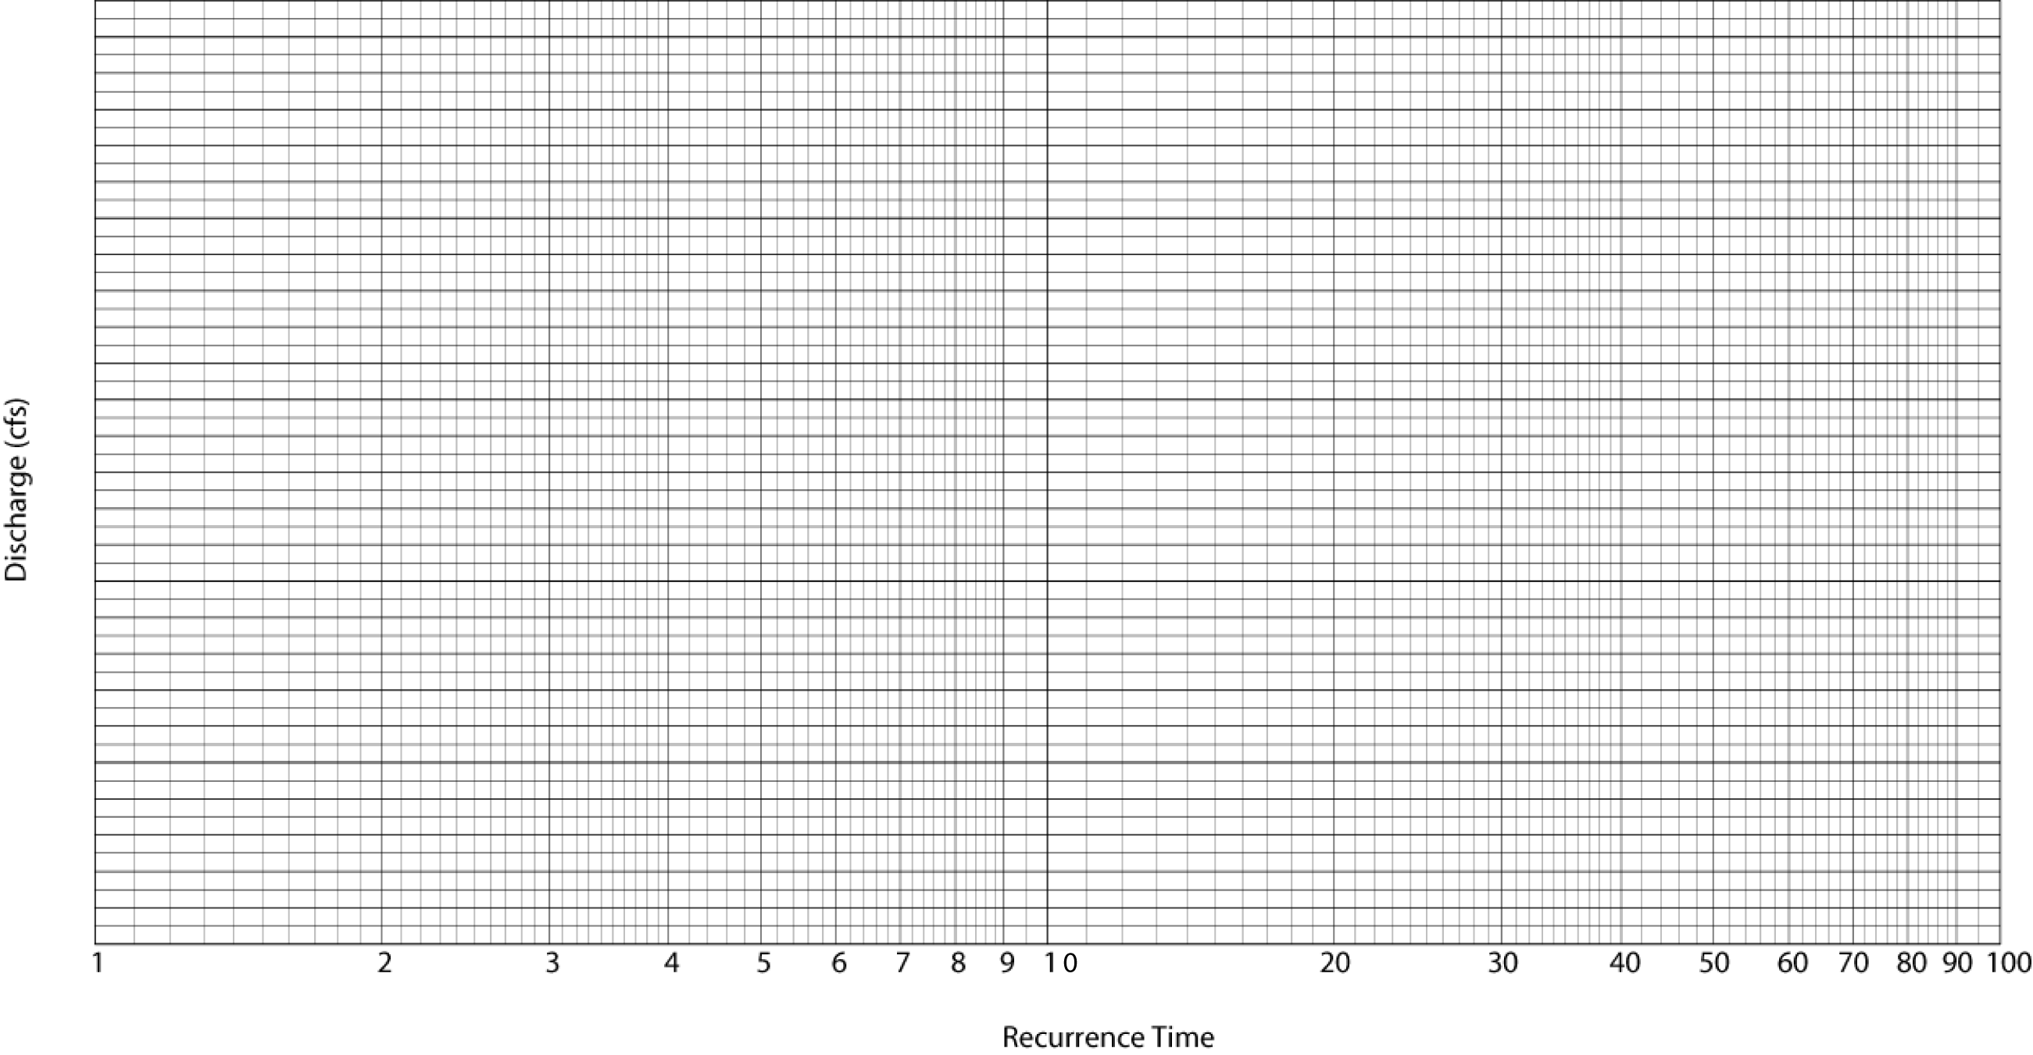

Then, use the gauge height and discharge data to construct another graph that will enable you to extrapolate to the gauge height of the 100-year flood.

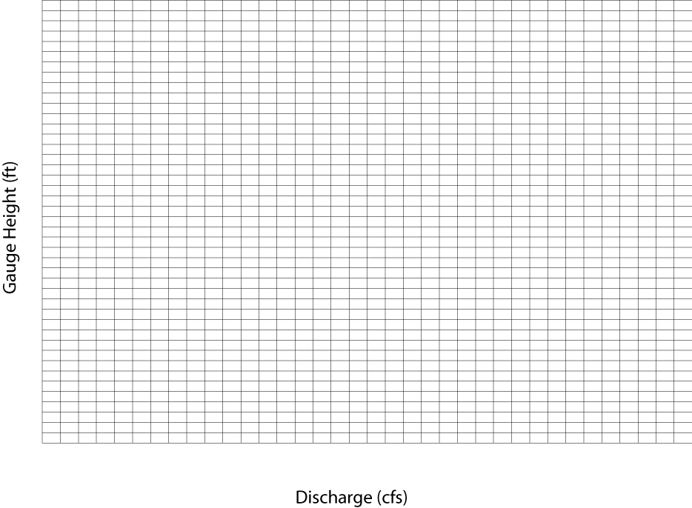
Write your results here:
100-yr discharge:

100-yr flood height:

How does your clast-inferred flood height compare with the 100 year flood? Use the graphs above to estimate the discharge and recurrence time of the clast-moving flow event:

Clast-Inferred Discharge

Clast-Inferred Recurrence Time

