Name
Lab Section
each group of two turns in one lab report

Geoscience 001 Fall 2006
Climate Modeling Lab

In this week’s lab, we are going to play around with a computer model of the global climate system. We will use this model to carry out a series of experiments that will help us understand some basic things about how our climate system responds to changes.

The model we will use was constructed in the STELLA program, which is a model-creation program similar to a object-oriented programming language, but it looks very little like a programming language and with just a little training, anybody can use the program and the models created by it.

Background on STELLA
If you take a few minutes to study the following link, you will see how STELLA models are made, how they relate to the real world, and what kinds of general systems concepts can be illustrated via these kinds of model. At a minimum, you should come to lab with a decent working knowledge of the key concepts discussed here (these are listed in the first screen):
http://www.geosc.psu.edu/~dbice/DaveSTELLA/STELLA_intro/intro.htm

Introduction to the STELLA Climate Model

The model we will use and the construction of it are described in some detail at http://www.geosc.psu.edu/~dbice/DaveSTELLA/climate/climate_modeling_1.htm#3 The model (shown below) consists of just two reservoirs (places where thermal energy is stored) and a bunch of flows that represent processes that transfer energy around the system. The energy being transferred is either short-wavelength radiation (coming from the sun), long-wavelength radiation (heat) coming from the earth surface or atmosphere, or latent energy tied up in water vapor and released upon condensation.

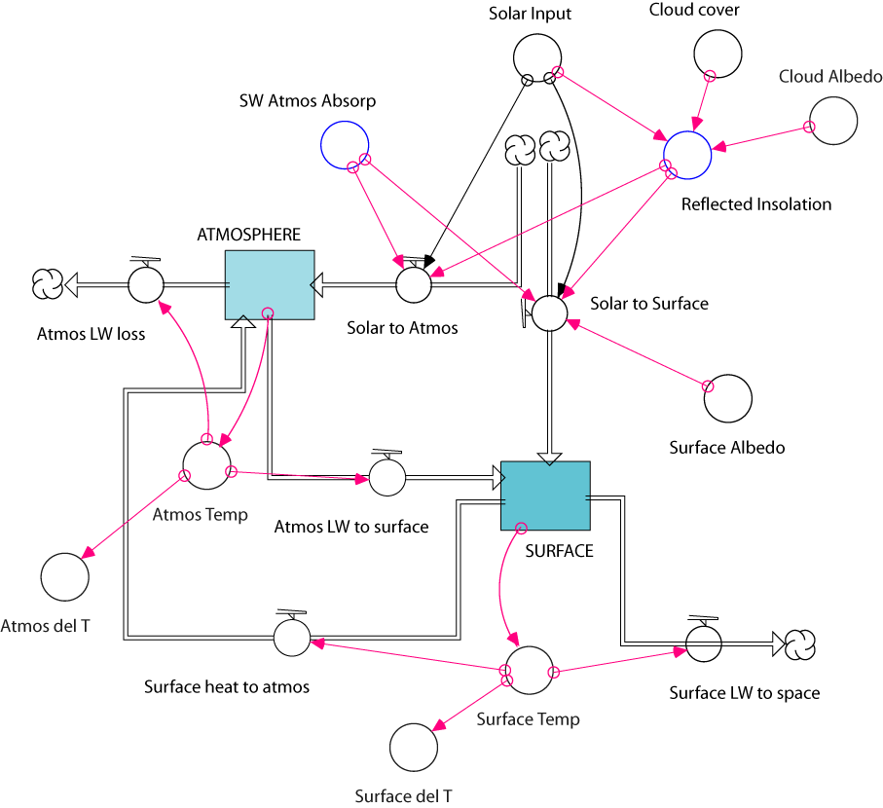

Get the model up and running first.

Download the model, find STELLA on the computer, and then open Climate model 1. Make a graph, double-click on it, then select Surface del T from the allowable column and transfer it to the selected column, then click OK to leave the Define Graph window. Next, run the model by selecting Run from the Run menu. Initially, the model should be in a steady state, with the Surface del T at 0°C. If this is not the case, get some help from a TA.

1. Turning up the Solar Input
How quickly, and by how much, does the climate model respond to changes in the solar input? Over the past 100 years, the Sun’s energy output has increased a bit, by 0.2% — so how much warming should this produce?

Change the Solar Input from 100 to 100.2, increasing the solar energy added to the system by 0.2%. Run the model for 10 years and see what happens.
a) How quickly does the system reach a steady state?

b) How much warming occurs?

c) In reality, the global temperature has increased by about 0.8°C over the last 100 years. Is a 0.2% increase in solar radiation a good explanation for the observed warming?

Next, change the Solar Input converter to include a sinusoidal variation, to mimic the seasons. Double-click on the converter and change it from 100 to 100+SINWAVE(1,1). This adds a sine wave variation with an amplitude of 1 (%) and a period of 1 (yr) to the base of 100 units of energy. Run the model for just 2 years and study the results to identify the lag times of the 2 reservoirs.
d) How much time separates the atmosphere and surface peak temperatures from the solar input peaks?

e) How do these lag times relate to the observation that the coldest time f the year in the northern hemisphere is usually in late January.

Return the Solar Input to 100 at the end of this problem, before moving on to the next.

2. Altering the Cloud Cover
What will happen if you change the percentage of the surface covered by clouds? It is initially set to 60% (0.6); let's first increase it to 70% and then decrease it to 50%.

a) First, study the model diagram carefully and make some simple predictions about how the model will react to these changes. How will the temperatures of the two reservoirs respond to an increase in cloud cover?

How will the temperatures of the two reservoirs respond to a decrease in cloud cover?

Will the system stabilize or will it change steadily for a long time?

Will the two altered cloud covers produce identical, though opposite results?

b) Now make the changes to the model and answer the following.
Relative to our initial model (the control in this experiment), how did the temperatures of the two reservoirs respond to an increase in cloud cover?

Relative to our initial model, how did the temperatures of the two reservoirs respond to a decrease in cloud cover?

Do the two altered cloud covers produce identical, though opposite results?

c) Do the model results here exceed the known behavior of the real climate system? If so, how might we modify our model to make it more realistic?

3. Cloud – Temperature Feedback
Next, we explore what happens if we make the cloud cover be a function of the global temperature. The reasoning behind this change is that when the Earth is colder, there will be less evaporation, therefore less water vapor to form clouds in the atmosphere, and conversely, when it is warmer, there will be more evaporation, more water vapor, and thus a greater percentage of the Earth covered by clouds. Download and open the Climate model 3, which has some modifications added —click on Cloud Cover to see how it is defined. This model also includes the original, unchanged model for the purposes of comparison. When you hit the Run command (under the Run menu), both models will operate and you can graph the same parameter from the two different models to better understand their differences.

a) What kind of a feedback mechanism is this (positive or negative)?

So, how does this change alter the way the system responds? To answer this, we need to throw the system out of whack, forcing some change from steady state. There are many ways to do this, but a simple one is to just increase the Solar Input to 102 (this will be applied to 2 models running in tandem here; one is the control model — the original version with no changes).
b) Make a prediction about how the temp-cloud feedback will change the model’s response to increased solar input.

Now run the models and study the results — might help to graph the two Surface Temps and the Cloud Cover of the altered model.

c) How did this change affect the magnitude of temperature change of the reservoirs?

d) How did this change affect the response time of the system?

e) In the modified model, how much did the Pct Cloud Cover actually change?

4. Removing the Greenhouse
Now we move on to a more severe modification, investigating the behavior of our model upon removal of the greenhouse effect. Open a version of Climate model 1 and make sure that it is in a steady state first by running it and graphing the surface temperature. The simplest way to make the change is to remove the 108 units of energy transferred by radiation from the surface to the atmosphere and ship that to the Surface LW to space flow. Modify the Surface heat to atmos flow by replacing the 108 with 0; then modify the Surface LW to space flow by replacing the 8 with 116.

If we want to completely remove the greenhouse, that means that there would be no water vapor in the atmosphere, which means there would be no clouds. So, we need to change the Cloud Cover to 0.0.

Before running this cruelly modified version of the model, make a prediction first — try to guess how the various system components will react.
a) How did these changes affect the surface and atmosphere temperatures? Summarize the results.

Undo the changes you made to the model before proceeding to the next problem. Run the restored model to make sure it is in a steady state.

5. Enhancing the Greenhouse
Here, you will try to model the effect of enhancing the greenhouse, simulating what may happen in the near future as we continue to burn more fossils fuels and clear more forests, thus increasing the concentration of carbon dioxide in the atmosphere. Our goal is to model the effects of doubling atmospheric CO2. At present, CO2 accounts for perhaps 30% of the total greenhouse effect (108 units of energy). You might imagine then that doubling CO2 would cause an increase of the Surface to Atmos flow of around 35 units, but you can see that this would create problems, because from our model, it appears that there are only 8 units of LW energy that are not absorbed at present. In fact, the actual change in energy trapped by a greenhouse gas generally decreases with increasing concentration. Another way of saying this is that the total amount of energy absorbed increases at a lower rate as the concentration of the gas increases. Calculations have shown that a doubling of CO2 is expected to increase the energy trapped by 5 W/m2, which is approximately 2 energy units in our model here. So, to modify our model, we change the 108 in the Surface heat to atmos flow to 110 and decrease the 8 in the Surface LW to space flow to 6 units. How much warming do you think this will produce? For reference, keep in mind that over the last 100 years, the global temperature appears to have increased by about 0.8°C while the concentration of atmospheric CO2 increased by about 20% (going from about 290 ppm to 350 ppm). After you've thought about this and made a prediction, run the model for 10 years and see what happens.
a) How does this change affect the temperatures of the two reservoirs? Summarize the results and compare them with the range of surface warmings predicted by more sophisticated super-computer models — from 1.5 to 4.5°C..

b) How does this experiment differ from what will probably happen in the real world over the next 100 years — think of how quickly the change was imposed in our model versus how quickly the change will occur in the real world?

