Carbon Cycle Homework Problems (due next Wed)

1. Implications of IPCC Scenarios.

Use the three IPCC emissions scenarios and find out what they imply in terms of atmospheric CO₂ levels and global temperature. These scenarios are for fossil fuel burning only; the changes related to land use are not specified, so let’s hold them steady at the year 2000 level. These emissions scenarios only go out to the year 2100, so we’ll end the simulation then.

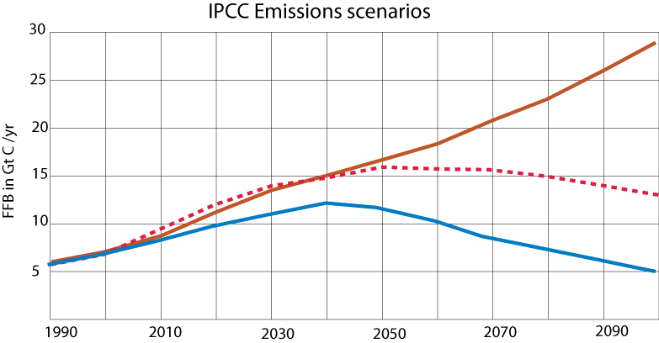

High Scenario: Atm pCO2 = Global T change =

Medium Scenario: Atm pCO2 = Global T change =

Low Scenario: Atm pCO2 = Global T change =

2. What is the relative importance of fossil fuel emissions vs. land use changes? Use the historical record (1880 to 2000) and figure out the relative effects of these two perturbations to the carbon cycle. You can do this by disabling one perturbation, running the model, and then disabling the other one. Report the effects in the table below and then comment on which of these is the most important perturbation.

Reservoir | Change in Gt C at t=2000 | Change in Gt C at t=2000
 | Fossil fuel burning only | Land use changes only
Atmosphere
Land biota
Soil
Surface Ocean
Ocean Biota
Deep Ocean
Grand Total
Atm pCO2
Global T change

3. Stallard (1990) hypothesized that there was a considerable amount of soil carbon stored in recent fluvial deposits — soil carbon that was not transferred to the surface ocean. The idea is that land use changes related to the expansion of agriculture led to a huge increase in soil erosion, dumping more sediment into streams than the streams could transport, resulting in the deposition of the carbon- rich topsoil’s in the flood plains of rivers, and also behind the numerous dams that were built in this same time period. Let’s explore what this might do the carbon cycle by disconnecting the flow from the Soil reservoir and sending that eroded carbon into another reservoir that we will call terrestrial sediments. The effect of this is most easily seen by replicating the standard model and then running the two models at the same time, for the historical time period. How big of an impact does this have on the cycle? How does the altered model then compare with the observed record of atmospheric CO2?

4. One “fix” that has been discussed for our changing climate is to enhance the biological pump in the carbon cycle by adding iron dust to the southern oceans, where a paucity of iron (a minor nutrient) appears to limit productivity. Use the high emissions scenario from problem 1 and then try changing the biological pump beginning in the year 2020. The way the model is structured, if you change the biological pump and not the net productivity, then the amount of carbon in the marine biota will decrease to 0, so you should change the flow of carbon into the marine biota in the same way you change the biological pump. Increase the pump by a fixed amount and hold that change until the year 2100. How big of a change is needed to bring CO2 levels down to the level it was at in 2000? Show how you modified the model and show the results of the model in terms of atmospheric CO2, global temperature change, and changes to the oceanic reservoirs.

Extra credit. Create your own emissions scenario, where the consumption and burning of fossil fuel is limited by a finite amount of carbon (4200 Gt C) and also by simple economics, by which the cost of the fossil fuels is a function of how much remains, and the burning of fossil fuels is sensitive to cost. So, as the supplies dwindle, the cost goes up and so we burn less, relying on some other energy source, and as we burn less, the reserves are not depleted as much. Show how you modify the model and explain your reasoning behind the changes, then show the resulting history of fossil fuel burning and the changes to the carbon cycle.

