**Carbon Cycle Modeling**

In this next modeling exercise, we tackle the global carbon cycle. We will use the model to carry out a series of experiments that will help us understand some basic things about the operation and future prospects for our carbon cycle.

The model we will use and the construction of it are described in detail in the document called Carbon cycle processes on ANGEL.

The model is a bit more complicated than the climate model we worked with last time, as can be seen by the diagram:

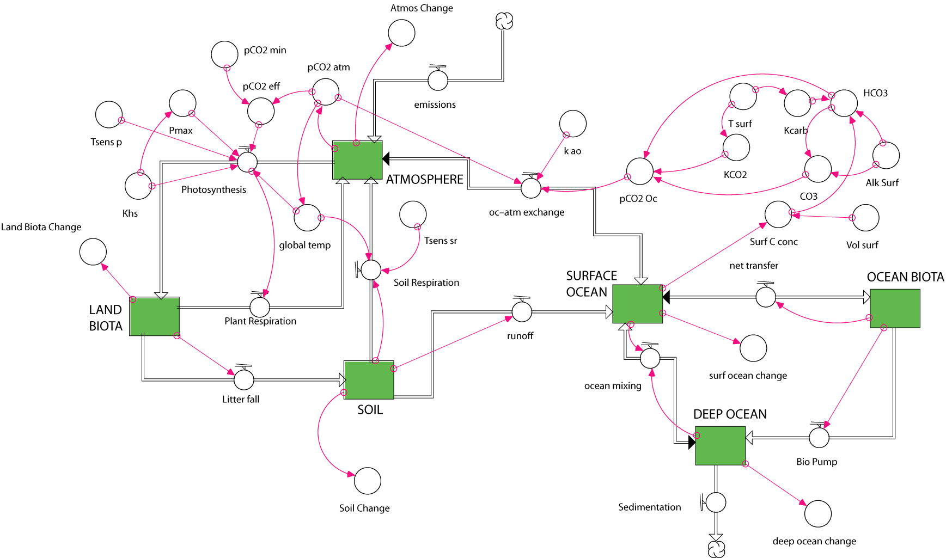

Most of the complexity arises from the way that photosynthesis and ocean carbonate chemistry are represented. In fact, the system is so complex that it cannot be set into a perfect equilibrium using STELLA. If you run the basic model, you’ll see that everything changes, but the magnitudes of these changes should be so small (compared to the changes we’ll impose) that they do not matter and we can consider the basic model to be in a steady state.

**1. Check to make sure that the initial model is approximately in steady state.**

**2. Make connections between fossil fuel burning, tree burning, and soil disruption to the appropriate flows and reservoirs to add the combined anthropogenic effects.**

**3. Run the model and see if the model atmospheric CO2 history matches the observed. You can fine tune your model to get it closer by playing around with the temperature sensitivities and the Khs for photosynthesis.**

**4. Where does the anthropogenic carbon go?**

This carbon cycle model does not have a missing sink – that is, all the carbon can be accounted for. Using the standard model with the anthropogenic effects, find out where the carbon goes by graphing the Atmos Change, Surf Ocean Change, etc converters — these give the amount of carbon added to or subtracted from each reservoir. Run the model for just the first 100 years, which amounts to starting 100 years ago and running to the present time.

a) Where does all the carbon go? Summarize the changes of all reservoirs by completing the table below.

|  |  |  |
| --- | --- | --- |
| **Reservoir** | **Amount added in Gt C** | **% of Total Added C** |
| Atmosphere |  |  |
| Land biota |  |  |
| Soil |  |  |
| Surface Ocean |  |  |
| Ocean Biota |  |  |
| Deep Ocean |  |  |
| Grand Total |  |  |