Names

Lab Section

Geoscience 001 Fall 2005
Carbon Cycle Modeling Lab

work in groups of two; each group hands in one lab

In this week’s lab, we are going to experiment with a computer model of the global carbon cycle. We will use this model to carry out a series of experiments that will help us understand some basic things about the operation and future prospects for our carbon cycle.

The model we will use and the construction of it are described in some detail at http://www.geosc.psu.edu/~dbice/DaveSTELLA/Carbon/c_cycle_models.htm - construct2
If you scroll down the first page, you will see a link that should download versions of the model that you will need to answer the questions in this lab.

The model is a bit more complicated than the climate model we worked with last time, as can be seen by the diagram:

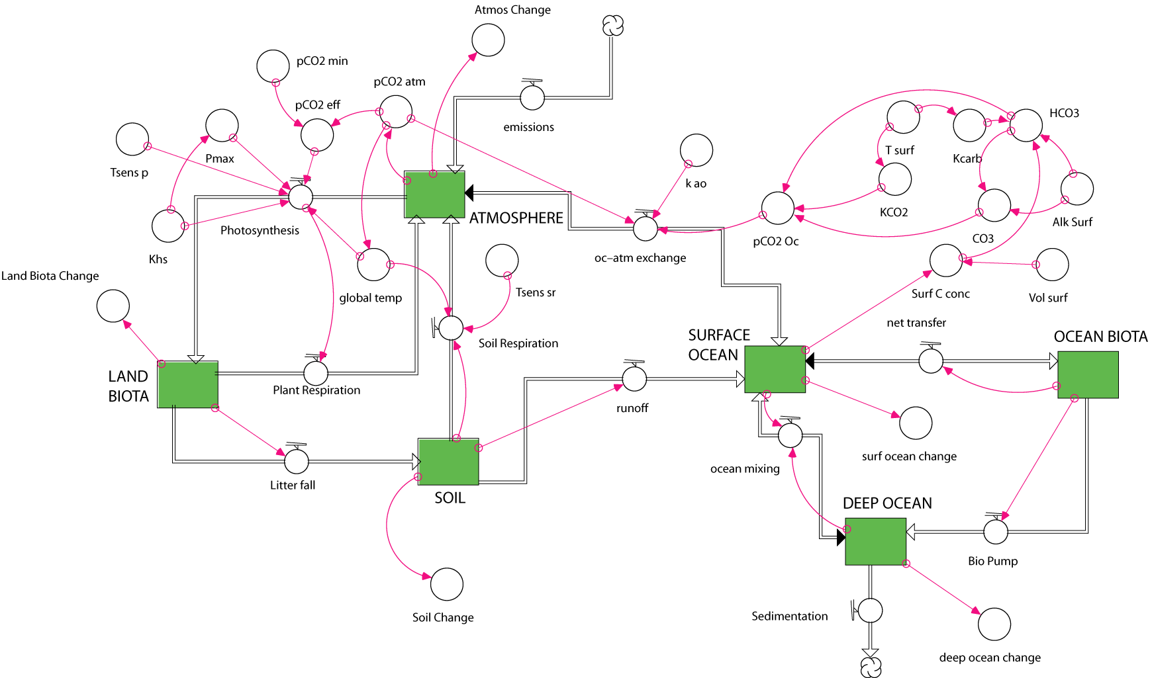

Most of the complexity arises from the way that photosynthesis and ocean carbonate chemistry are represented. In fact, the system is so complex that it cannot be set into a perfect equilibrium without going to extreme lengths. If you run the basic model, you’ll see that everything changes, but the magnitudes of these changes are so small (compared to the changes we’ll impose) that they do not matter and se can consider the basic model to be in a steady state.

1. Where does the anthropogenic carbon go?

This carbon cycle model does not have a missing sink – that is, all the carbon can be accounted for. Using the standard model with the anthropogenic effects, find out where the carbon goes by graphing the Atmos Change, Surf Ocean Change, etc converters — these give the amount of carbon added to or subtracted from each reservoir. Run the model for just the first 100 years, which amounts to starting 100 years ago and running to the present time.

a) Where does all the carbon go? Summarize the changes of all reservoirs.

b) Compare the model’s calculated history of atmospheric CO2 concentration (pCO2 atm) with that of the real world (observed atm CO2) — are they close? Does the model do a perfect, a decent, or a poor job of matching the observed record?

2. Business–as–Usual (BAU)

In this model, I have extrapolated the curves for fossil fuel burning and land use changes (forest burning and soil disruption) for an additional 200 years. I’ve done this extrapolation conservatively, trying to continue the trend of the recent past. Now run the model and see what happens.

a) What is the atmospheric CO2 concentration (pCO2 atm) at the end of this time?

b) How does that compare with the present?

c) How hot does the planet get?

d) How do the proportions of the changes compare with those observed in the first 100 years? I.e., are the changes linear (constant slopes) or non-linear?

3. Stabilization

Let’s imagine that we manage to keep fossil fuel emissions and land-use changes to the carbon cycle at the current levels for the next 200 hundred years — what will happen? To do this, change the ffb graph so that from year 100, the value of ffb is 6.0 (the units here are Gigatons of carbon per year) — this makes fossil fuel burning constant over the rest of the model time. Do the same for the land use changes graph (take the year 100 value and extend it out to year 300).

a) Does this halt the warming?

b) How hot does the planet get?

c) Describe what happens to the temperature after the stabilization takes begins (year 100).

d) How long does it take the system to approach a new steady state? You may need to extend the length of time the model runs for, by selecting the Time Specs menu from the Run menu.

4. Enhancing the Ocean Biota + Stabilization

Let’s see what happens if we enhance the oceanic biota, bumping it up by 2 Gt C/yr (the flow is initially defined to be 10 Gt C/yr). Leave the ffb and land-use changes set as they were for the last experiment, make a connector arrow between OceanBio Enhance and the flow from the surface ocean reservoir to the ocean biota reservoir (net transfer). Doing this will make a question mark appear inside the net transfer flow, meaning that it needs attention. Double-click on that flow and you’ll get a window that defines what that flow is. In the upper left, you’ll see a list called Required Inputs — including your new OceanBio Enhance converter. In the lower half of the window, you’ll see the equation for the flow as it was previously defined (should be 10*(Ocean_Biota/INIT(Ocean_Biota)). Put the cursor at the end of this equation, click once, then type a plus then click on OceanBio Enhance from the list on the upper left — this should complete the equation and you are ready to go; exit this window and be sure that the question mark has disappeared. Run the model for the full 300 years and study the results

a) Describe the effects of this enhancement — how does this model compare with no enhancement?

b) Is this 20% enhancement enough to halt the warming and lower the temperature to the model temperature at time 100 (which represents the present day)?

5. Full Stop

First, disable the OceanBio Enhance converter from the previous experiment. Then, explore the consequences of completely halting fossil fuel emissions and land-use changes to the carbon cycle. To do this, change the ffb graph so that after year 110, it drops to 0 and stays there for the rest of the time Do the same for the land-use changes graph. Then run the model and see what happens.

a) Describe what happens to the global temperature.

b) If you run the model out longer, does it return to the same temperature that it began at?

