Names

Lab Section

Geoscience 001 Carbon Cycle Modeling Lab

work in groups of two; each group hands in one lab

In this week’s lab, we are going to experiment with a computer model of the global carbon cycle. We will use this model to carry out a series of experiments that will help us understand some basic things about the operation and future prospects for our carbon cycle.

The model we will use and the construction of it are described in detail at http://www.geosc.psu.edu/~dbice/DaveSTELLA/Carbon/c_cycle_models.htm - construct2

The model is a bit more complicated than the climate model we worked with last time, as can be seen by the diagram:

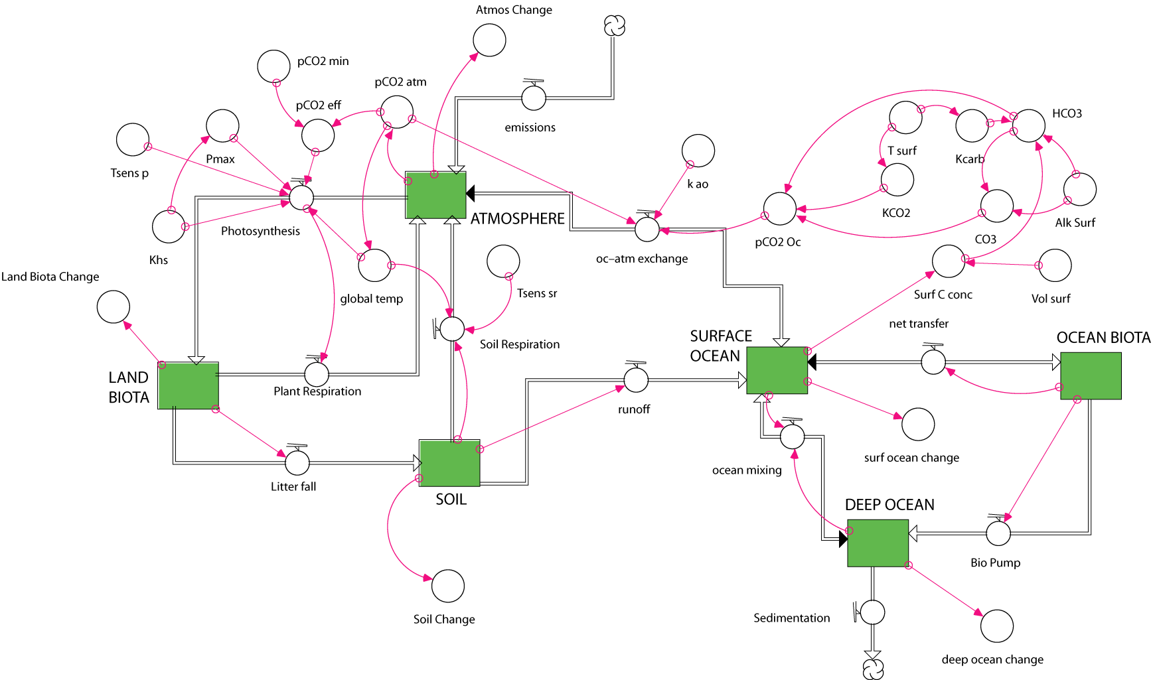

Most of the complexity arises from the way that photosynthesis and ocean carbonate chemistry are represented. In fact, the system is so complex that it cannot be set into a perfect equilibrium without going to extreme lengths. If you run the basic model, you’ll see that everything changes, but the magnitudes of these changes are so small (compared to the changes we’ll impose) that they do not matter and se can consider the basic model to be in a steady state.

1. Where does the anthropogenic carbon go?

This carbon cycle model does not have a missing sink – that is, all the carbon can be accounted for. Using the standard model with the anthropogenic effects, find out where the carbon goes by graphing the Atmos Change, Surf Ocean Change, etc converters — these give the amount of carbon added to or subtracted from each reservoir. Run the model for just the first 100 years, which amounts to starting 100 years ago and running to the present time.

a) Where does all the carbon go? Summarize the changes of all reservoirs by completing the table below.

Reservoir | Amount added in Gt C | % of Total Added C
Atmosphere | 194.7 | 73.75
Land biota | 31.6 | 11.9
Soil | -42.5 | -16
Surface Ocean | 17.1 | 6.5
Ocean Biota | 0 | 0
Deep Ocean | 63.1 | 23.9
Grand Total | 264 | 100

b) Compare the model’s calculated history of atmospheric CO2 concentration (converter labeled pCO2 atm) with that of the real world (converter labeled observed atm CO2) — are they close? Does the model do a perfect, a decent, or a poor job of matching the observed record?

Decent job

2. Business–as–Usual (BAU)

In this model, I have extrapolated the curves for fossil fuel burning and land use changes (forest burning and soil disruption) for an additional 200 years. I’ve done this extrapolation conservatively, trying to continue the trend of the recent past. Now run the model and see what happens.

a) What is the atmospheric CO2 concentration (pCO2 atm) at the end of this time?
2121 ppm

b) How does that compare with the present?
present is 357 ppm, so this is ~6 time more

c) How hot does the planet get?

18.4 °C hotter than the start (start is 15°C), so 33.4°C

d) How do the proportions of the changes compare with those observed in the first 100 years? I.e., are the changes linear (constant slopes) or non-linear?

Reservoir | Amount added in Gt C | % of Total Added C
Atmosphere | 3946.4 | 80.2
Land biota | 443 | 9
Soil | -634.6 | -12.9
Surface Ocean | 103.7 | 2.1
Ocean Biota | 0 | 0
Deep Ocean | 1064.1 | 21.6
Grand Total | 4922.5 | 100

The changes are obviously much greater, and the proportions change somewhat — more and more of the carbon is taken up by the atmosphere, less and less by the oceans and the land biota; the soil continues to be a source rather than a sink, but it is less of a source, in terms of percentage of the whole.

3. Stabilization

Let’s see what happens if we manage to keep fossil fuel emissions and land-use changes to the carbon cycle stable for the next 200 hundred years. Doing this will not be easy, but it can be achieved via a variety of measures summarized in the paper on carbon “wedges”, which is linked to the syllabus.

First, we need to change the converters called ffb and land use changes.
Double-click on ffb and you’ll see a graph like this:
Place the cursor on 7.100 in the ffb column on the right of this window, then click, hold, and drag the mouse down; you’ll see the years scroll down to 300, then release the mouse button.
Now enter a value of 6 in the Edit Output box, then click the OK button to make the changes and exit the window. This should have changed the ffb values for years 110 through 300 to a value of 6.0.

Double-click on the ffb converter again, then scroll along the graph to be sure that the changes worked — you should see a flat line from year 100 to 300.

Do the equivalent change to the land use changes converter (take the year 100 value and extend it out to year 300).

a) Before running the model, make a prediction — will this halt the warming? Include your reasoning, along with your prediction.

look for some reasonable statement

b) Does this halt the warming?
No — the arming continues, but at a lesser pace and not in an accelerating way

c) How hot does the planet get?
3.5°C warmer than the initial temperature (so 18.5°C total)

d) Describe what happens to the temperature after the stabilization takes begins (year 100).
The temperature continues to rise, but at a lesser pace, a shallow slope — but it shows no sign of leveling off

e) Does the system approach a new steady state? You may need to extend the length of time the model runs for, by selecting the Time Specs menu from the Run menu (don’t go more than a couple thousand years).

it does not approach a steady state, at least within 3000 years, and in fact, the rate of change slightly increases over this time — bad news.

4. You Fix It
Congratulations — you have been placed in charge of bringing the global carbon cycle and thus the global climate under control. The fate of the world (well, at least the temperature) rests in your hands. Take a deep breath as you contemplate the power.

Your recommendation to the world will be based on model simulations so that people understand exactly what must happen and when we can expect stabilization and the sooner, the better.
There are some constraints, however:
- You cannot drop the emissions to a level below 6 Gt/yr
- You can do whatever you want to the land use changes
- You cannot rely on some mythical technology to scrub CO₂ from the atmosphere.

To begin, you need to study the model carefully and think about whether or not you can enhance some flow process to solve the problem.

Look at each flow and ask yourself whether or not changing it will affect the atmosphere directly or indirectly and whether or not a change is feasible.

Here is an example of a change that is not feasible: increasing downwelling of ocean water, which brings surface waters down into the deep ocean — there is no reasonable way of controlling something like this. Another change that could not be feasible is to drastically lower the ocean temperature.

Your solution should begin at time 100, which is the present day.

The following example (which may or may not be reasonable) shows the general strategy for making such a change — follow along so that you get the hang of it. Let’s say we want to see what will happen if we increase the transfer of carbon from soil to the surface oceans through the process of runoff (this is also called soil erosion, and has some unpleasant consequences). First, you make a new converter, called enhance and connect it to runoff as shown below:
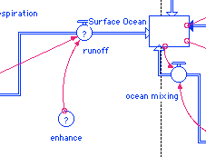
Then double-click on enhance and you’ll see a window that is used to define the converter. Type IF TIME<100 THEN 1 ELSE 2 into the blank space, as shown below:
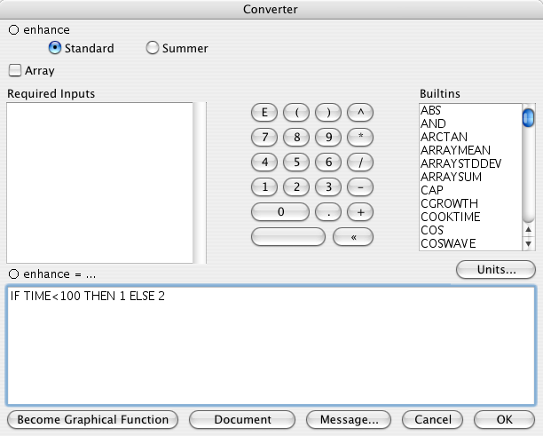
Then click OK to exit this window. Next, double-click on the runoff flow and modify the equation described there so that enhance is multiplied by the pre-existing equation, as shown here:
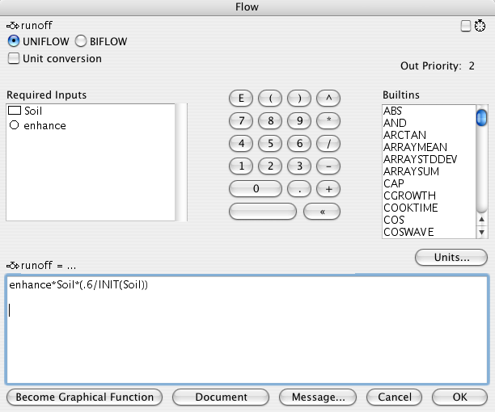
Click OK to exit and the model is ready to run. Study what happens by graphing the global temp converter and see what happens following time 100. Does the change work? Apparently not. So, you need to be creative and try a variety of changes to find a solution.

What is Your Solution?
Describe the change you made (in enough detail so that we can replicate it — if we can’t replicate it, you will not get full credit) and show a graph of the global temperature from time 0 to 300 to demonstrate the success of your change. Also, discuss what would have to happen in the real world to make your change a reality.
Here are some ideas that work:
1. Enhancing ocean biota by a small amount can have a very strong effect — it expands the ocean biota, which then becomes more effective drawing up carbon from the surface waters, which is then quickly transferred to the deep ocean. This requires spreading the right fertilizer around the world’s oceans on a regular basis, which is a big task.
2. Building more dams and reservoirs to trap carbon that is normally transferred from soils to the oceans. You can create a new reservoir and divert some fraction of the soil carbon into this box. This requires building dams downstream of areas undergoing soil erosion, which is not without consequences.
3. Enhancing photosynthesis will also do the job — but it’s not as easy as you might think. You have to really increase the photosynthesis — like by a factor of 3 or 4 to have a long-lasting impact. The reason for this is that the plant respiration flow will also increase.
4. Make a big pipe from the atmosphere into the deep ocean — could be done, but pretty tough to generate the power to pump so much air down so deep.
5. Reduce land-use changes substantially. This is probably the easiest thing to do in terms of fiddling with the model.

