MatSE 259
Exam 1 – Fall 2007

Only one answer per question. For a few questions, you may feel that more than one answer works; choose only the best answer.

- Code your Penn State ID# on your answer sheet now.

1. Steel A contains 0.2C; steel B contains 0.6C. Both are in the same heat treatment condition. The tensile strength of steel A is

- a. greater than that of steel B
b. less than that of steel B
- c. equal to that of steel B
- d. none of the above

2. Quenching and tempering a steel usually

- increases its strength
- decreases its strength
- doesn’t change its strength
- steels are not quenched and tempered

3. In general, which changes the internal structure of an alloy

- a. mechanical working
- b. heat treatment
- c. change chemical composition
- d. all of the above
- e. none of the above

4. All aluminum alloys

- a. contain carbon
- b. contain copper
- c. have melting points in excess of 1500° C
- d. contain manganese
- e. have mass densities lower than those of steels

5. Grain boundaries

- a. don’t exist in ordinary metals and alloys
- b. don’t exist in amorphous materials
- c. exist in single crystals
- d. have no effect on dislocations
- e. cannot be moved

6. According to the Aluminum Association numbering system for aluminum alloys, 2024 indicates:

- an Al-Mg-Si alloy
- an Al-Cu alloy with 0.24 % C
- an Al-Cu alloy with 2.4 % C
- an Al-Cu alloy with 2.4 % Cu
- an Al-Cu alloy

- Failure type for this specimen

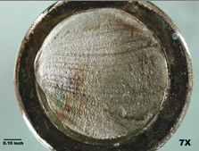

- a. failure in tension
- b. brittle failure
- c. fatigue failure beachmarks
- d. impact failure

8. Failure type for this specimen

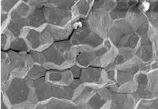

- a. ductile failure
- b. brittle failure intergranular
- c. fatigue failure
- d. transgranular failure

9. Failure type for this specimen

- a. ductile failure – note extensive shape changes
- b. brittle failure
- c. fatigue failure
- d. failure in tension

10. Failure type for this specimen

- a. ductile failure grains ripped apart – fracture surface not very distinct - dimpling
- b. brittle failure
- c. fatigue failure
- d. intergranular failure

Below are four types of specimens for mechanical testing. For questions 11-14, choose the specimen for each test given. Use all specimens; use each only once.

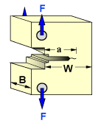
a

b


c
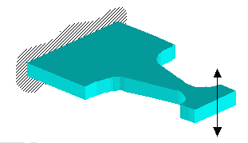
d
11. Fracture toughness a

12. Fatigue d

13. Tensile test b

14. Impact test c

15. Order for increasing elastic moduli

- metallic alloys, ceramic materials, polymers
- metallic alloys, polymers, ceramic materials
- ceramic materials, metallic alloys, polymers
- polymers, ceramic materials, metallic alloys
- polymers, metallic alloys, ceramic materials

16. Possible age hardenable alloy system solution treat, quench, age

d
a
b
c

17. Calculate the % RA from these tensile test data: d_{o} = 12.8 mm, l_{o} = 50.8 mm, d_{f} = 8.2 mm, l_{f} = 63.8

- 13
- 0.59
- 76
- 26
- 59 (πr_{o}² – πr_{f}²)/ πr_{o}²

18. Indentor for what test?

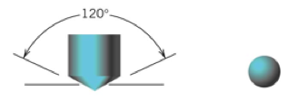
indentation shape

- Vickers
- Brinell
- Rockwell B
- Rockwell C RB, Brinell –ball indenter; Vickers, Knoop – pyramidal indentation
- Knoop

19. Response curve for what test?

- creep
- fatigue
- tensile
- hardness
- impact

20. Layer sequence for ccp crystal structure

a. ABABABAB
b. ABACABAC
c. ABCABCABC
d. ABCBACABAB
e. AABBCCAABBCC

21. Number of slip systems for ccp crystal structure

a. 12
b. 4
c. 3
d. 6
e. 24

22. Number of close packed planes in the A2 (“bcc”) crystal structure

a. 12
b. 4
c. 6
d. 1
e. 0 there are 6 densely packed planes in this structure, but they are not close-packed

23. Work hardening

a. Metal or alloy becomes stronger when all dislocations disappear
b. Metal or alloy becomes weaker when dislocations become harder to move
c. Metal or alloy becomes stronger when dislocations multiply in number
d. Metal or alloy becomes stronger when the number of slip systems decreases upon deformation
e. Metal or alloy becomes weaker when dislocations multiply in number

24. Not a method or procedure for strengthening alloys

a. work hardening
b. solution hardening
c. precipitation hardening
d. grain size reduction
e. annealing softens

25. 718

a. Al casting alloy
b. alloy steel with 0.18C
c. complex alloy which has a Ni matrix 718 is a Ni-based superalloy
d. iron-based superalloy
e. newly developed alloy (in 1999) which has very few applications

