MatSE 259 - Fourth exam Fall 2005
Put student number on answer sheet
Only one correct answer for each question

50 minutes

1. – N – R – N – C – R – C –

H H O O

a. polypropylene
b. nylon
c. epoxy resin

2. – N – – N – C – – C –

H H O O

a. polyethylene
b. aramid
c. polycarbonate

3. Calendaring

a. adding a plasticizer to a polymer
b. drawing a polymer to fiber
c. rolling a polymer with fiber or fabric reinforcement

4. Conventional way to bond rigid PVC parts together

a. coat surfaces to be bonded with a plasticizer
b. coat surfaces to be bonded with an epoxy glue
c. plastically deform the surfaces to be bonded after heating

5. CH₃ CH₃

– Si – O – Si – O –

CH₃ CH₃

a. polyphenylene oxide
b. high T_{g} polymer
c. silicone

6. CH₃

– – C – – O – C – O –

CH₃ O

a. Plexiglas
b. polycarbonate
c. polymethylmethacrylate

7. Role of matrix in FR composites

a. add strength to the composite
b. make the material flexible
c. transfer applied loads to the fibers

8. Bond angle in – C – C – C – chain
?°
a. 109.5°
b. 180°
c. 90°

9. You are using a tube of silicone insulating caulk. Upon expelling the material from the tube, you notice a pungent odor. This indicates that

a. the plasticizer is evaporating
b. crosslinking is taking place
c. the monomer is polymerizing

10.
H H

– C – C –

Cl H

a. requires high temperatures in order to form
b. can only be drawn to fibers (no other shapes possible)
c. a plasticizer is added for forming

11. Fibers in FR polymers are frequently coated with a thin layer of a “coupling agent”. Why?

a. the polymer/fiber bond is strengthened
b. it prevents chemical degradation of the fiber by the polymer
c. it prevents degradation of the polymer by the environment

12. Aramids are similar in structure to nylons. However, the structural differences result changes in properties. What is largely responsible for the large increase strength in the aramids?

a. amide group
b. phenyl group
c. both a and b

13. NEEDED IN A HURRY!!! Material for 100,000 simple leaf springs to be used to hold a polymer film against a plate. What’s of greatest importance?

a. recyclability
b. cost
c. availability

14. Which of the following would probably not be an issue in choosing a material for the manufacture of an inexpensive reusable metal lid for a food canning jar:

- formability
- recyclability
- corrosion resistance

15. Viscous flow of polymers

a. occurs by shear
b. shear rate is not important
c. only occurs below T_{g}

16. Shear thinning

a. reduction of cross-sectional thickness by a cutting operation
b. phenomenon which depends upon shear rate
c. occurs in polymers only below T_{g}

17. My polymer melt won’t flow properly in forming. Possible solution?

a. increase shear rate
b. decrease shear rate
c. lower the temperature

18. Highest T_{g}

a.
b. 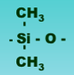
c. 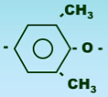

19. Tenacity

a. denier of polymer fibers
b. breaking strength of polymer fibers
c. interface bond strength in FRPs

20. In ceramic matrix composites, fracture toughness of the ceramic matrix is not improved by

a. crack tip deflection
b. redistribution of stresses around crack tips
c. impeding dislocation motion

21. Crosslinking in polymers

a. vulcanization of rubbers is an example
b. decreases T_{g}
c. increases formability

22. Responsible for toughness of polycarbonates

a. aromatic phenyl groups in chain
b. CO₃ groups in chain
c. both a and b

23. When polymers are drawn, what happens to the stiffness of the material?

a. increases
b. decreases
c. no change

24. Which stress-strain curve is for a partially crystalline polymer below T_{g}?

a
b
c

25. Consider materials for structural members in house construction. You want strong and cheap. What are possibilities? Choose P = 6.8 and above.

- softwoods (ex: pine) and cheap steels
- concrete and GFRPs
c. stainless steels (SS) and PVC

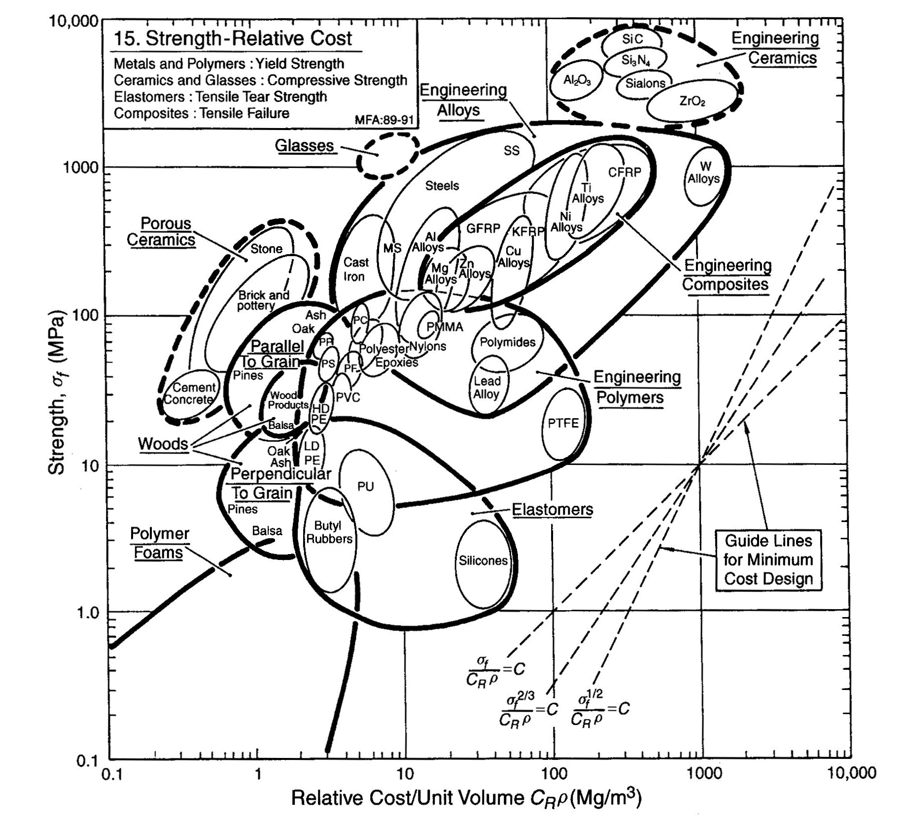
Use this one

which has stiffest chain
order of crystallite movement diagrams
affects tg
11/16
which stress-strain for crystalline polymer (slide 10-11/18)
which probably fails by crazing
polymer stiffness – crystallinity, crosslinking tg
polymer is drawn – what happens to stiffness?
11/18
11/21
11/22
11/28
11/30
12/2
12/4
example of blow molding
11/11
11/9

