Final exam

You may use a calculator and your white card, but nothing else, and consult no one except the instructor.
If the English for a problem is confusing, ask for an explanation.
Use English as much as possible.

1. List four methods for the preparation of specimens for powder x-ray diffraction from a properly ground sample. Comment on the possibility of preferred orientation for each method. 1 min.

slide - strong preferred orient.

front - some preferred orient.

back – a little preferred orient.

side drift – little to none preferred orient.

2. In AuBe5 (see powder x-ray diffraction pattern on last page) , there are Au atoms in 4a (000), and Be atoms in 4c () and
16e (xxx, xx, xxx, xx), x = .

What is I210? ___0____ pattern is OBVIOUSLY F cubic !!

Calculate the intensity for the sixth reflection ___3.305 x 10⁸______
(Ignore scale factor, absorption, and temperature factor). Carefully show all calculations; fill in the blank table on the next page. λ = 1.541838 Å
Lp = (1 + cos2 2θ)/sin2 θ cos θ) Show ALL of your work. 20 min.

(hkl) dhkl (sin θhkl)/λ ƒhkl Fhkl

(400) 1.5203 .3289 1.671 54.89 214.55
______________________________________________________________
2

Be:
(sin θ)/λ 0.0 0.1 0.2 0.3 0.4 0.5 0.6 0.7
ƒ 4 2.9 1.9 1.7 1.6 1.4 1.2 1.0

Au:
(sin θ)/λ 0.0 0.1 0.2 0.3 0.4 0.5 0.6 0.7
ƒ 79 73.6 65 57 49.7 43.8 39.8 36.2

2θ = 60.94, θ = 30.47, 1/d = .50709 x 2/1.541838 = .65777, d = 1.5203

Be: 1.7 - .1 x .289 = 1.671 Au: 57 – (57-49.7) x .289 = 54.89

F(400) = 4 (54.89 (1) + 1.671 (1 + 2 exp (2πi (4 x 5/8) + 2 exp (-2πi (4 x 5/8))
= 219.56 + 1.671 (1 + 2 x 2 cos (2π (5/2))) = 219.56 + 1.671 x (-3)
= 219.56 – 5.013 = 214.55

p = 6 Lp = (1 + (cos (60.94))²)/((sin (30.47))² x cos (30,47)) =
(1 + .2359)/(.2571 x .8619) = 1.2359/.2216 = 5.577

I(400) = 6 x 5.577 x (214.55)² = 3.305 x 10⁸

3. What parts of the instrument are common to all of these: SEM, TEM, EPMA? I.e., what instrument components are essentially the same for all three of these instruments?
30 sec.

electron gun & electromagnetic lenses

4. List at least 5 different ways in which a specimen shows contrast in a reflected light microscope.
2 min.

1. Different phases may be delineated due to differences in reflectivity. The reflectivity varies with wavelength, so contrast may be changed through the insertion of a filter.

2. Crystals of different orientations are etched at different rates. This results in contrast due to the ledges formed at grain boundaries.

3. Etchants frequently attack grain boundaries preferentially leading to grain boundary grooving.

4. Etchants may facet the grains. The faceting is different for differently oriented grains.

5. Etchants often attack different phases at different rates. This leads to surface relief.

6. Some etchants can be caused to stain the sample surface so that the differently oriented grains and different phases take on varied colors.

5. Describe the ZAF correction in detail, and discuss how the correction is carried out.
5 min.

Z – at. no. correction
Function of electron backscattering factor &
electron stopping power - depend upon the average
at. nos. of unknown and standard

Varies with composition and accelerating voltage

A – absorption correction
Varies with μ, takeoff angle, accelerating voltage

F – fluorescence correction
primary fluorescent x-rays ––> secondary fluorescent x-rays

Varies with composition and accelerating voltage

Can't calculate ZAFs unless concns known. Use k values
(I/I° = k) to estimate compositions of each element.
Then calculate ZAFs, and refine by iteration

6. On the following pages is a series of images and other results from possible electron microscopy instrumentation: SEM (scanning electron microscopy), TEM BF (transmission electron microscopy), TEM DF (transmission electron microscopy), ED (electron diffraction), EDS (energy dispersive spectroscopy), EPMA (electron probe microanalysis), SEs (secondary electrons) and BSEs (backscattered electrons). Mark each image (I_{upper}, I_{lower}, II, III, IV, V) with the appropriate label or labels from the list above. Give reasons for your answers; what features and/or information did you use to make your decision?. (Ignore the tiny grid-like dot pattern due to the computer scanning of half-toned photos.)

What are the dark straight-line segments in Ia? Explain.

What is so obviously strange or unusual about II? Neither the presence of a large number of "spots" or some of the spots are larger or more intense is the answer. Give a reason for your answer. 3 min.

I.

TEM BF DF pair note scale and general overall features. Black lines are precipitates – oriented in matrix grain + show up white on DF image.

II.

ED 10-fold symmetry!! Not allowed…….?? This is for a "quasicrystal"

III.

SE - topographic contrast

IV.
EPMA - image + element maps (or possibly SEM) (a) is BSEs

V.

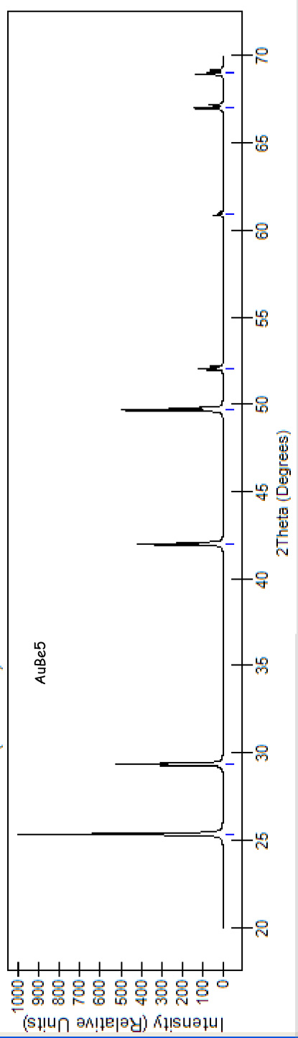
X
X

